THE DALLES
COLUMBIA RIVER
THE DALLES, OREGON
MAJOR REHABILITATION EVALUATION REPORT
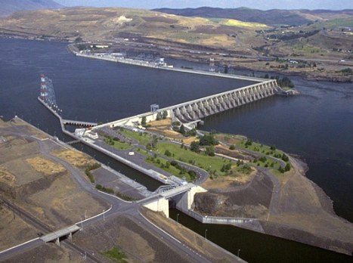


SEPTEMBER 2019

THIS PAGE IS INTENTIONALLY LEFT BLANK

EXECUTIVE SUMMARY

The main effort of this Major Rehabilitation and Evaluation Report (MRER) centers around the aging spillway of The Dalles Lock and Dam. The focus of this report is to assess, quantify, and catalogue the major deficiencies of the spillway and/or areas of particular interest to The Dalles Dam Project and Northwest Division, with the goal of identifying critical spillway component to receive major rehabilitation funding to conduct repairs and remediation to extend the longevity of the Project.

A benefit-cost ratio is calculated to determine the value of a significant major rehabilitation investment. The ratio weighs the expected consequences due to failures of systems or components of the Project and compares those consequences (in the form of capital loss) to the expected future benefits (risk buy-down) of a large capital investment to preemptively address known deficiencies of those systems.

The Project Delivery Team (PDT) has provided analysis for this report in six main areas: electrical reliability, mechanical reliability, structural reliability, environmental consideration, component and project costs and repair estimates, and economic impact and forecasting analysis. The PDT has developed a list of deficiencies or points of concern for the following spillway components: higher than anticipated friction in Tainter gate trunnion systems, aging mechanical Tainter gate hoist equipment, aging or antiquated spillway controls and power distribution, the aging original 30 ton spillway gantry crane with stoplogs and lifting beam, and undercutting and erosion of the spillway stilling basin apron slabs and concrete appurtenances.

In the process of estimating consequences to flood passage, navigation, power production, fish passage and recreation, the PDT found that due to The Dalles Dam’s “run-of-river” authorization, overall consequences are comparatively low when considering projects whose authorization is flood risk management centered.

More to follow is subsequent reviews.

TABLE OF CONTENTS

1 Introduction 8
1.1 Project Authorization and Federal Interest 8
1.2 Purpose and Scope 8
1.3 Location and Description 9
1.3.1 Location 9
1.3.2 Significant Project Features 9
1.3.3 Project Area Characteristics 12
1.4 Report Contents 14
2 Project History 15
2.1 History and Components of The Dalles 15
2.1.1 Rockfill Closure Dam 15
2.1.2 East Non-Overflow Dam 16
2.1.3 Powerhouse 17
2.1.4 South non-overflow Dam 18
2.1.5 Spillway 18
2.1.6 North Non-overflow Dam 22
2.1.7 Navigation Lock 22
2.2 Historical Levels of Service 22
2.3 Service Disruptions with Consequences 22
2.3.1 Tainter Gate Service Disruptions 22
2.3.2 Spillway Bridges Load Ratings 25
2.3.3 Spillway Uplift Investigation 26
2.3.4 Spillway Apron Erosion and Undercutting 27
2.3.5 Navigation Lock Filling and Emptying Valve Repairs and Replacement 31
2.3.6 Navigation Lock Downstream Miter Gate Replacement 32
2.3.7 Navigation Lock Upstream Radial Gate Replacement 32
2.4 Historical Repair Costs 33
2.5 Routine Maintenance Costs 35
2.6 Periodic Inspection Reports 35
2.7 Operational Condition Assessments (OCAs) 35
2.8 Periodic Assessment Report 36
2.9 Geotechnical Analysis 36
2.9.1 Seismic Safety Review (SSR) 36
2.9.2 Site-Specific Seismic Hazard Analysis 36
2.9.3 Rock Anchor Test Program 37
3 Identification of Problems and Opportunities 38
3.1 Component Identification, Screening, and Selection 38
3.2 Alternative Strategies for Investment 43
4 Engineering Reliability and Evaluation 44
4.1 Spillway Structural 45
4.1.1 General 45
4.1.2 Reliability Analysis 45
4.1.3 Failure Mode Description 45
4.1.4 Investment Strategies 47
4.2 Spillway Mechanical Equipment 48
4.2.1 General 48
4.2.2 Reliability Analysis 48
4.2.3 Failure Mode Description 48
4.2.4 Investment Strategies 49
4.3 Spillway Controls 49
4.3.1 General 49
4.3.2 Reliability Analysis 50
4.3.3 Failure Mode Description 50
4.3.4 Investment Strategies 51
4.4 Power Distribution 52
4.4.1 General 52
4.4.2 Reliability Analysis 52
4.4.3 Failure Mode Description 52
4.4.4 Investment Strategies 54
5 Economic Analysis 55
5.1 Purpose 55
5.2 Methodology/Procedure 55
5.3 Description of Model 55
5.4 Baseline Condition 55
5.5 Benefits 55
5.6 Costs 55
5.7 Alternative Plans 55
5.8 Evaluation 55
6 Environmental Considerations 56
6.1 Background 56
6.2 National Environmental Policy Act (NEPA) 57
6.3 Endangered Species Act (ESA) 57
6.4 Clean Water Act (CWA) 58
6.5 National Historic Preservation Act (NHPA) 59
6.6 Other Environmental Laws and Regulations 59
7 Project Cost Estimate 59
7.1 Project Cost Components 59
7.1.1 Tainter Gate Replacement - Mechanical 59
7.1.2 Tainter Gate Replacement - Structural (Single End Frame Replacement) 59
7.1.3 Tainter Gate Replacement - Electrical 60
7.1.4 Plates and Stiffeners - Structural 60
7.1.5 Trunnion Rehabilitation - Structural 60
7.1.6 Spillway Gantry Crane – Electrical, Mechanical, Structural Combined 60
7.1.7 Emergency Stoplogs 61
7.1.8 Emergency Closure System – Electrical, Mechanical, Structural Combined 61
7.2 Replacement Costs 61
7.3 Advance Maintenance Costs 62
8 Recommended Plan 63
8.1 Plan Features 63
8.1.1 Rehabilitation of Spillway Gates 1 through 9 63
8.1.2 Rehabilitation of Spillway Electrical Distribution System 64
8.1.3 Rehabilitation of Spillway Electrical Control System 64
8.2 Economic Considerations 64
8.3 Construction Considerations 64
8.4 Schedule 64
8.5 Other Recommendations 64
8.5.1 Major Maintenance Effort 64

FIGURES
Figure 1-1: Vicinity Map 9
Figure 1-2: The Dalles Lock and Dam Project Overview 10
Figure 1-3: The Dalles Lock and Dam Project Features 10
Figure 2-1: View of rockfill closure dam crest. Settlement of the crest can be observed by locking at the low point of the guardrail and parapet wall. 16
Figure 2-2: The Dalles East Non-Overflow Dam and East Fish Ladder between the Rockfill Closure Dam and the Powerhouse. 17
Figure 2-3: The Dalles Powerhouse, view from the Oregon Shore 17
Figure 2-4: The Dalles South Non-Overflow Dam connects the Powerhouse and the Spillway. 18
Figure 2-5: The Dalles Spillway 18
Figure 2-6: Spillway Gantry Crane 19
Figure 2-7: Radial Tainter Gate End Frame 24
Figure 2-8: Spillway Uplift Gauge Locations (Source: DDD-1-4-2/1. PIR No. 1, and PIR No. 2) 26
Figure 2-9: General Overview of Spillway and Training Wall Areas Surveyed for Erosion 28
Figure 2-10: 2018 Bathymetry Comparison with 2013 and Previous 30
Figure 2-11: Approximate Region of Concrete Erosion in Bay 1 (Erosion Concentrated Around Construction Joints) 31
Figure 8-1 Hills Creek Dam Rehabbed Spillway Gate System 63

TABLES
Table 1: Pertinent project data and characteristics 13
Table 2: Current Status of Tagged Spillway Gates. 23
Table 3: Historical Repairs to the Navigation Lock at The Dalles. 33
Table 4: Historical Repairs to the Spillway at The Dalles. 33
Table 5: Historical Repairs to the Powerhouse at The Dalles 34
Table 6: Historical Repairs to the Non-overflow Dams at The Dalles 34
Table 7: Historical Repairs to the Fishways at The Dalles. 34
Table 8: Routine O&M Costs at The Dalles 35
Table 9: Components considered for detailed analysis in the RER. 42

APPENDICES
APPENDIX A COMPONENT EVENT TREES
APPENDIX B RELIABILITY WORKBENCH MODELS
APPENDIX C COST INFORMATION
APPENDIX D @RISK MODELING
APPENDIX E STRUCTURAL CALCULATIONS
THE DALLES LOCK AND DAM
COLUMBIA RIVER
THE DALLES, OREGON

MAJOR REHABILITATION EVALUATION REPORT

Introduction

Project Authorization and Federal Interest
The Dalles Lock and Dam was originally authorized by the Flood Control Act of 1950. The dam was constructed to produce hydropower, provide river navigation and fish passage. The Dalles Lock and Dam is the penultimate dam on the Columbia River before it flows into the Pacific Ocean. Construction of the project began in 1952 and was completed in 1957 with commissioning in 1960. The dam is operated as part of the Columbia River Basin system of dams.
The Dalles pool extends 24 miles upstream. The pool provides slack water navigation to John Day Lock and Dam and inundated two significant historic/cultural sites – Celilo Falls and The Dalles-Celilo Canal. Celilo Falls is an important cultural asset to indigenous Native American tribes of the region. The spring and fall salmon runs attracted thousands of Native Americans to Celilo Falls. Salmon provided a large, consistent component of the diet and economy of the Native Americans along the Columbia River.
The Dalles slack water pool inundated and replaced the need for the historic The Dalles-Celilo Canal. The Dalles-Celilo Canal was an older USACE navigation project that included five locks and 8.5 miles of canal. The Dalles provides $823.9 million in annual public benefits including hydroelectric power generation, navigation, fish and wildlife conservation, improved water quality, and recreation.

Purpose and Scope
Engineers and Operations staff at The Dalles Lock and Dam (The Dalles) have documented numerous problems with the aging mechanical, electrical and structural components. Without proactive planning and preparation, any resulting prolonged project closures and their potential consequences would be severely disruptive to navigation, hydropower, and fish passage. This Major Rehabilitation Evaluation Report (RER) was initiated due to project reliability concerns following a Periodic Assessment (PA) completed in 2018 which identified a high-degree of concern for the poor performance and reliability of The Dalles. The RER establishes the engineering condition of a structure and determines the need for reliability or efficiency improvements.
The Major Rehabilitation Evaluation Report (RER) identifies the recommended strategy which is most economically efficient in addressing the known deficiencies and improving reliability of the existing project. The methodology of the evaluation conforms to ER 1130-2-500, supplemented by EP 1130-2-500, dated 27 December 1996, including incorporating risk and uncertainty and applying probabilistic analyses of reliabilities of major project components. The engineering reliability and risk for the RER will be conducted in accordance with EC 1110-2-6062. The focus of this RER is primarily centered on the spillway and its appurtenances. The navigation was not considered due to ongoing projects regarding the lock and its systems (discussed in later sections). The RER presents the results of the evaluation of the present condition, present and future reliability, and consequences of unreliability of various key components of The Dalles Dam.

Location and Description

Location
The Dalles is located on the Columbia River at the head of Bonneville Lake, 192.5 miles upstream from the mouth of the river and 3 miles east of The Dalles, Oregon (Figure 1-1). The Oregon-Washington state boundary lies along the main Columbia River channel, dividing the project between the two states. The entire project, except for a portion of the rockfill closure dam, is in Washington.
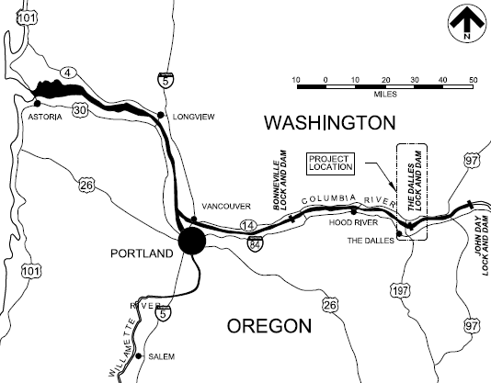
Figure 1-1: Vicinity Map

Significant Project Features
The Dalles Dam consists of a powerhouse, concrete spillway, navigation lock, three concrete non-overflow sections, a small rockfill embankment on the Washington shore, a large rockfill embankment on the Oregon shore, and fish passage and appurtenant facilities. The dam is 8,735 feet long, including embankments. In 1989, The Northern Wasco County People’s Utility District (PUD), installed a 5MW one turbine powerhouse on the northern fish way attraction water supply. This powerhouse is non-federal publically owned agency under the jurisdiction of the Federal Energy Regulatory Commission (FERC) and first operated in 1991. Figure 1-2 shows the major project features identified. Pertinent data and project characteristics are list in section 1.5 below.
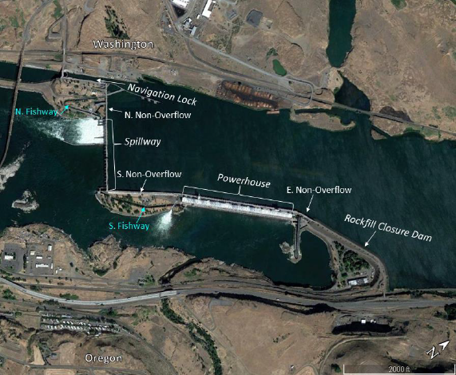
Figure 1-2: The Dalles Lock and Dam Project Overview

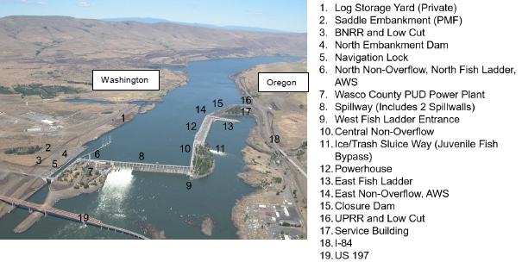
Figure 1-3: The Dalles Lock and Dam Project Features

Rockfill Closure Dam
The rockfill closure dam crosses the deepest section of the river at the project site, and was the last portion of the dam constructed that provides the closure of the dam with the Oregon shore. The dam is 2,017-feet long, with a maximum height and width of 285-feet and 1,400 feet, respectively. The Closure dam was founded on hard basaltic lava flow bedrock and consists of un-compacted quarry-run rock, spoils and gravel. The closure dam permanently retains a pool under 85 feet of hydraulic head. The embankment is comprised of about 3,000,000 cubic yards of quarry-run rock, spoils and gravel, which were deposited by end-dumping the material through water without compaction. Seepage control is provided by upstream filter zones and a semi-pervious sandy gravel seepage control blanket. The lower portions of the dam were constructed in wet conditions by end dumping the material and were not compacted.

East Non-Overflow Dam
The east non-overflow dam is a 452-foot long concrete gravity structure. The dam is over 100-feet high and is located between the rockfill closure dam and the powerhouse. Approximately 80% of the returning adult salmon use the East Fish Ladder which is located on the east non-overflow dam.

Powerhouse
The powerhouse is a 2,089-foot long concrete gravity structure, is over 200-feet tall, and accommodates 22 main power unit generators with a plant capacity rating of 1,806,800 kW. The 14 main powerhouse units (1-14) began operation in October 1960. Powerhouse units 15 through 22 went into operation between December 1972 and October 1973. In addition to the main power generators, the powerhouse also includes two fish turbines and two station-service units which were installed during the same phase as Main units 1-14. The powerhouse is located between the south and east non-overflow dams.

Central (South) Non-Overflow Dam
The central non-overflow dam, similar to the east non-overflow dam, is a 1,527-foot long concrete gravity structure. The dam is over 100-feet high and is located between the powerhouse and the spillway.

Spillway
The spillway is 1,447 feet long and consists of 23 radial gate controlled bays separated by 10-foot wide piers. The radial gates are 50-feet wide by approximately 43-feet high and are numbered 1 to 23 from right to left looking downstream. The spillway gates have a maximum elevation of 162.0 feet. The entire crest design discharge is 2,290,000 cfs under a total head of 61.3 feet.
In 2004, a training wall between Bays 6 and 7 was constructed through the stilling basin to reduce mortality in endangered juvenile salmonid fish spill operations. In 2010, a longer spill wall was constructed between Bay 8 and 9 to improve juvenile salmonid fish egress during the fish spill operations. The 832-foot long 8/9 training wall extends from the spillway to the west end of the spillways shelf and is curved to direct fish towards the river thalweg leaving the dam. In order to keep the spillway flow north of the 8/9 training wall, the spillway gates 1-8 are prioritized for fish spill operations. Per 2018 Fish Passage Plan, the bay 1 - 8 spillway configuration can discharge up to 40% of a total river flow of 423 kcfs, or 169 kcfs. When project flows exceed these levels, spill must be discharged outside (or south) of the spillway with a biological preference for gates operated sequentially north to south (i.e., gate 9 first when needing to operate beyond gates 1-8).

North Non-Overflow Dam
The north non-overflow dam concrete gravity structure is 574.06 feet long and consists of one block 34 feet long and nine blocks each 60 feet long. The non-overflow section is constructed on the same alignment as the spillway dam from the spillway to the navigation lock. The North Non-overflow section abuts the lock just upstream from the upper gate and contains the stop log slots for the upstream bulkhead and the high flow wing bulkhead. This section houses the intake for the north fishway attraction water supply and the Northern Wasco County PUD and the north fishway. PUD water intake is through the Corps Auxiliary Water Supply (AWS) system. The PUD maintains AWS/power intake fish screens, penstock and a 5 MW hydropower unit.

Navigation Lock
The navigation lock consists of a single lift lock chamber, concrete upstream and downstream guide walls (land side of channel), a concrete upstream guard wall, a rockfill downstream guard wall and a filling and emptying system. The single lift navigation lock is 86 feet wide by 675 feet long with a maximum vertical lift of 90.5 feet and a minimum operating depth of 15 feet at the sill. The approaches to the lock within the shipping channel are protected by guard walls which extend 1,060 feet upstream and 1,170 feet downstream. With an established minimum Bonneville pool elevation of 69.5 feet NGVD29 (73.3 feet NAVD88) the elevation of the sill of the lower gate is 54.5 ft NGVD29 (57.8 feet NAVD88), with the resulting net draft of 15 feet at minimum tailwater elevation and 18 feet for normal low tailwater. The downstream gate consists of two miter leaves and the upstream gate is a submersible Tainter gate. The filling and emptying system consists of a vortex-like intake structure, a culvert tunnel into the lock chamber, and discharge laterals downstream of the miter gate. Filling and emptying laterals are located in the central part of the floor of the lock chamber. The filling and emptying system is operated entirely by force of gravity and by the manipulation of Tainter valves in the culverts.

Dam Safety Instrumentation
Instrumentation at The Dalles Dam includes survey targets and monuments to measure deflections; foundation drains and weirs to monitor foundation seepage; uplift gauges at the spillway to monitor foundation uplift pressures; and piezometers at the powerhouse to measure foundation uplift pressures. In general, survey data show no excessive deflections or settlements of the concrete structures. Foundation drain flows and uplift pressures are also within design limits and appear to follow historic patterns. A review of the instrumentation and inspection results as provided in the latest Periodic Inspection Report (PIR) No. 11, dated March 2018, indicate that the dam and appurtenant works appear to be stable and safe for continued operations under normal non-emergency conditions. Performance during unusual or extreme loading conditions such as during an MCE seismic event or PMF flood event is unknown pending seismic re-evaluation and hydrologic capacity investigations, respectively. To review the instrumentation reading schedule, program summary and analysis, location inventory details and table, drawings, and data plots see Appendix E of the PIR which is provided as a reference to the RER.
1

Project Area Characteristics
All elevations in this report are in the North American Vertical Datum of 1988 (NAVD88) per ER 1110-2-8160. The project was designed and referenced to the National Geodetic Vertical Datum of 1929 (NGVD29). To obtain NAVD88, 3.27 feet was added from NGVD29.

NID Number | OR00002
Drainage Area (square miles) | 237,000
Pool Elevations NGVD29 (NAVD 88)
Normal maximum pool | 160.0 (163.3 NAVD88)
Normal minimum pool | 155 (158.3 NAVD88)
Spillway
Type | Concrete gravity, gate controlled
Length | 1,447 ft
Gates | (23) 50-ft wide Tainter gates
Crest elevation | 121.0 (124.3 NAVD88)
Deck elevation | 185.0 (188.3 NAVD88)
Design Discharge (pool el. 182.3) | 2,290,000 cfs
Maximum discharge through spillway to date | 700,000 cfs
(est. total river flow)
Central non-overflow dam length | 1,527 ft
Powerhouse
Turbine type | Kaplan automatic adjustable blades
Number of units | 22 main units
Turbine capacity | 14 @ 123,000 hp at 81 ft head
 | 8 @ 140,000 hp @81 ft head
 | 1,806,800 kW total generating capacity
Length | 2,089 ft
East non-overflow dam length | 452 ft
Rockfill closure dam length | 2,017 ft
Total length of dam | 8,735 ft
Navigation Lock
Type | Single lift
Normal lift | 87.5 ft
Maximum lift | 90.5 ft
Inside clearance | 86 x 675 ft
Minimum depth over lower sill | 15 ft
Depth over upper sill (pool el. 160) | 20 ft
Upstream sill elevation | 140.0 (143.3 NAVD88)
Downstream sill elevation | 54.50 (57.8 NAVD88)
*Navigation lock is typically closed to traffic at river flows higher than 500,000 cfs
Table 1: Pertinent project data and characteristics
The Dalles is near the western edge of the Columbia Plateau physiographic province. The surface is formed by a thick accumulation of Miocene basalt flows or by sediments mantling those flows. Regional faults have influenced the development of topographic features and the course of the Columbia River at the site.
Subsurface exploration for the spillway, tailrace, and approach channels included 67 rock core borings, 36 power probe holes, and one trench. This subsurface exploration was judged adequate to characterize the nature of the overburden materials, thickness and character of basalt flows, and to delineate the surface of the bedrock.

Report Contents
This report presents the study findings relating to development of the RER in accordance with Appendix B of EP 1130-2-500, Rehabilitation Evaluation Report, dated December 27, 1996. Key parts include:
- Section 1, General Information on the project to include project authorization, location, and description.
- Section 2, Captures Historic inspections, Evaluations, repairs, and navigation usage.
- Section 3, Describes the Initial Screening process that identified problems and opportunities based on the historical reports and knowledge.
- Section 4, Project Components carried forward after the initial screening process. This section describes the baseline condition and reliability of selected project components along with investment alternatives for ensuring the continued operation of the project.
- Section 5, Economic Analysis of the baseline condition and the alternatives.
- Section 6, Environmental considerations for the final components under consideration for investment.
- Section 7, Conclusions and recommendations
- Section 8, Classification
- Section 9, Project cost estimate for recommended plan
- Section 10, Cost sharing Considerations.

Project History
Historic information in the RER includes: brief summaries of each significant feature and supporting infrastructure; recent operation and maintenance issues; and recent report summaries. The brief history contained within this section establishes the foundation as to why major rehabilitation is needed at The Dalles. In-depth details can be found in the Appendices.
Recent historical information contained within the RER includes: Bridge Inspections; Periodic Inspections (PI), Periodic Assessment (PA 2018), Operational Condition Assessments (OCAs), Hydraulic Steel Structures (HSS) inspections and reports and geotechnical analysis. Older records of inspections and evaluations of The Dalles are not included within this report. However, an extensive listing of such records is available upon request and is located within the SQRA.

History and Components of The Dalles
The dam construction began in February 1952 and was completed with the installation of the rockfill closure in April 1957. The last of the main powerhouse units (1-14) began operation in October 1960. Powerhouse units 15 through 22 began operation between December 1972 and October 1973.
Past evaluation and inspection reports on The Dalles tend to be written on separate major features. These major features are labeled within Figure 1-2. A brief description of the history and components of each major feature follows.

Rockfill Closure Dam
The rockfill closure dam is located across the deepest part of the river and has shown continued settlement over the history of the project. The accumulated settlement reached 1.65 feet by 1959 when the crest of the dam was restored to grade at elevation 185 feet, the railroad tracks realigned off the dam, and the crest road was repaved with asphaltic concrete. Since 1973, the closure dam has continued to settle approximately at its deepest section, Station 49+50. The most recent survey indicated that there was a total of 3.2 feet of settlement over 55 years, which is greater than the 1% guideline for embankments constructed of compacted materials. The settlement is believed to be caused by continuing consolidation of fill material and remained consistent with no notable acceleration or degradation of condition. Based on historical data, the rate of settlement appears to follow a typical logarithmic function (rapid settlement at first then slowing with time). Typically settlement on embankment dams won’t exceed 1-percent of the total height of the dam for The Dalles (2.85 feet). Embankments constructed of hydraulic fills, high plastic clays, uncompacted fills, or on poor foundation can have settlements in excess of 1% of the embankment height.
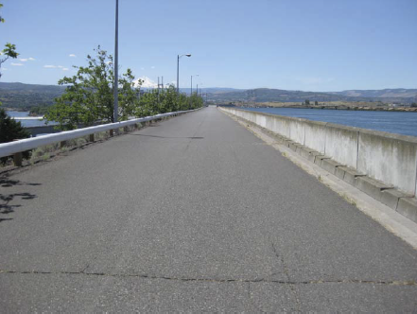
Figure 2-1: View of rockfill closure dam crest. Settlement of the crest can be observed by locking at the low point of the guardrail and parapet wall.

East Non-Overflow Dam
The east non-overflow dam is a 100-foot concrete gravity dam that connects the rockfill closure dam and the power house. Historical surveys have indicated that monoliths within the east non-overflow dam have undergone a maximum vertical movement of less than 0.3 inches and horizontal deflections of less than 0.5 inches since the baseline survey in 1990. These values are within acceptable limits.
Settlement has occurred in the fill beneath the East Fish ladder between the piers adjacent to the Junction pool and the entrance channel to the old fish lock. Previous inspections have observed settlement in the fill beneath the east fish ladder between the piers adjacent to the junction pool and the entrance channel to the old fish lock since at least 1998. Settlement was attributed to poorly compacted fill (possibly due to inability to get high compaction efforts immediately adjacent to the walls and columns), fines washing into the adjacent fish ladder, or both. As part of the auxiliary AWS contract, a valve room is now located under the ground surface at this area. This area will continue to be observed during annual inspections for reoccurrence of settlement.
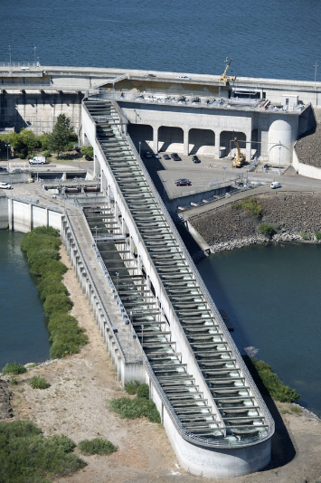
Figure 2-2: The Dalles East Non-Overflow Dam and East Fish Ladder between the Rockfill Closure Dam and the Powerhouse.

Powerhouse
The powerhouse was constructed under five major contracts. Three of these included all the excavation and the concrete for the substructure, and two for installation contracts. The work under these contracts was performed between February 1952 and August 1956. Total construction cost for the powerhouse was $19,304,359.
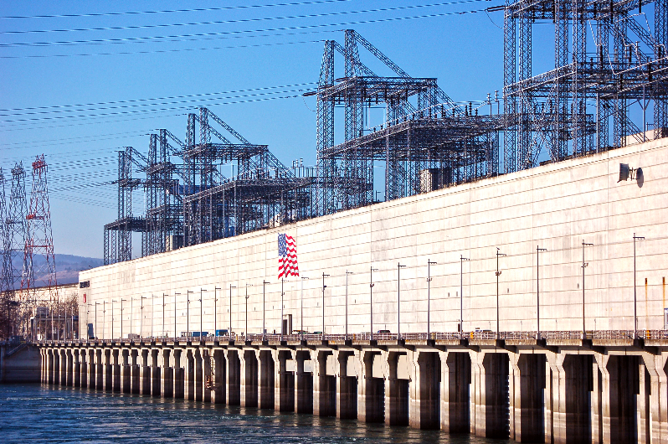
Figure 2-3: The Dalles Powerhouse, view from the Oregon Shore

South non-overflow Dam
The 2013 Periodic inspection noted the central (south) non-overflow dam was in good material condition. The items noted during the periodic inspection have been previously noticed and are not immediate concern.
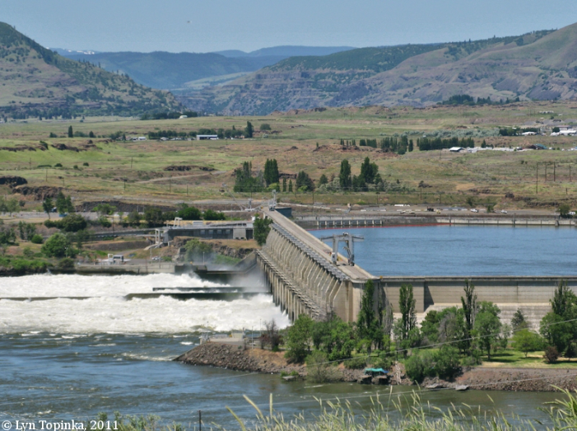
Figure 2-4: The Dalles South Non-Overflow Dam connects the Powerhouse and the Spillway.

Spillway
The Dalles spillway is comprised of 23 radial Tainter gates of which 8 are tagged out of service. See Section 2.3.1 for more details. Gates 1 through 8 are well maintained and are always used first as mandated for fish passage allowing the spillway flow to be contained and directed by the 8/9 training wall.
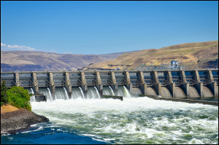
Figure 2-5: The Dalles Spillway

Spillway Gantry Crane
The gantry crane was manufactured by C.H. Jucho, Dormund, Germany in 1956 and many components have exceed their design life. The crane is located on the spillway deck and its intended uses are:
- The main hoist is rated for 30 tons and consist of two hoisting drums and hook blocks, each having a capacity of 15 tons, set 24 feet apart and driven by a single motor through a speed reducer and cross shaft. The main hoist is primarily used to handle the spillway stoplogs in conjunction with a lifting beam. Power for the crane is supplied by a diesel-generator set with a capacity of 75 KVA.
- The auxiliary hoists consist of two hoisting units each with a rated capacity of 10 tons. The hoisting units are identical except for the direction the hoist is reeved. Hoisting can operate independently, together as a single unit, or together as required to handle a grapple. The auxiliary hoists are mainly used for the removal and placement of concrete hatch covers to gain access to stoplogs for their placement or removal.
- All hoists are used occasionally, for general servicing of the spillway deck.

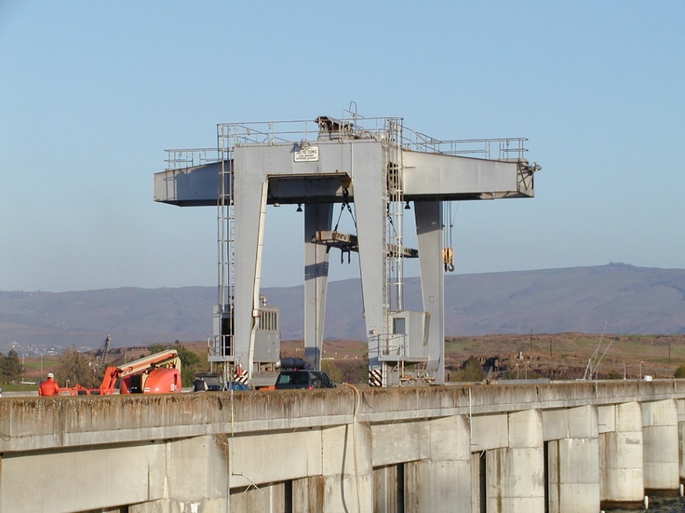
Figure 2-6: Spillway Gantry Crane
The crane is currently incapable of deploying stop logs under flow conditions (Tainter gate stuck open) in an emergency situation. There is concern that the downpull force generated on a stop log in flow would exceed the crane’s safe load capacity. The weight of each stop log section is approximately 12.5 tons. The maximum estimated downpull force, through 10 to 15 feet of lowering, is 45.0 tons. The resultant total load would thus be 57.5 tons and, on the basis of an overload factor of 25 percent, the required capacity would be need to be 46 tons. Therefore, in an emergency situation there is no immediate action that can be safely executed to cutoff flow in a particular spill bay. The crane is only capable of placing stop logs in a balanced head condition (Tainter gate fully closed). The stoplogs are not designed to be placed under flow.
In 2002, INCA performed an inspection of the Gantry Crane and recommended the replacement of the motors and brakes to ensure the system would provide reliable service for the next 30 to 40 years. The crane controls are past their design life, are obsolete, and obtaining replacement parts is becoming difficult. The report recommended replacing the existing crane magnetic controls with open loop VFD controls, replacing the existing diesel generator, three-phase and single-phase power distribution equipment, rubber insulated wiring, and crane wheels.
Operational Condition Assessments (OCAs) are maintained for all major components within each major systems at The Dalles. The OCAs rate each component on an “A” through “F” scale, “A” being “Adequate”, “B” meaning “Probably Adequate”, “C” meaning Probably Inadequate”, “D” meaning Inadequate, and “F” meaning “Failed.” The OCAs rated the crane machinery, structure and truck assemblies, and drive system as “Inadequate” and the Drive System as “Failed”. The OCA’s noted that the operator must ride brakes in order to minimize load swing and the brakes must be pumped to be useful. Continued crack propagation in the wheels was noted in the crane truck assembly and corrosion has been observed in the structural members. Crane power cuts out often and voltage output is unstable. The Drive system was rated as “F” (Failed) because not all cylinders fire properly (bypassing fuel to the exhaust), the confined engine room is a significant fire hazard, and the crane frequently leaks fuel and oil with no secondary containment.

Spillway Tainter Gates
Spillway Tainter gates are inspected every five years in accordance with Engineer Regulation 1110-2-8157, “Responsibility for Hydraulic Steel Structures”. Inspections are conducted by structural engineers utilizing industrial rope access techniques to perform close-up, hands-on inspection of the critical structural components of the Tainter gates. The first inspection evolution occurred in 2012 and included the downstream faces of Gates 1 through 23 and the upstream faces for Gates 6 and 18. Since this initial inspection, five gates were inspected in both 2016 and 2018. The out-year inspection plan is to inspect five gates per year so that each gate gets inspected every five years at most.

Spillway Bridge
The spillway bridge was designed for a 50-ton gantry crane and a 42-ton crawler crane with 20-ton lifting capacity. A 42-ton crawler crane, or other construction equipment of equal capacity, was assumed to be used by the contractor on the deck during construction. Expansion joints are provided at alternate piers. Stoplog openings are covered with removable concrete slabs so that two-way traffic may be maintained on the deck except for spans where these slabs would be removed for emergency work under the deck. Original plates for the spillway bridge indicate a steel superstructure. However, a decision was made prior to the finalization of Design Memorandum 1 (July 21, 1952) to design the bridge using reinforced concrete because of a steel shortage during the time the plans were being prepared, to reduce maintenance costs, and because of the comparable construction costs. The bridge superstructure consists of a girder on the upstream side and a box girder on the downstream side, which is used as an equipment and conduit gallery.

Spillway Mechanical
The Tainter gate operating machinery is located on the piers and abutments of the spillway dam downstream of the roadway deck. Individual operating units are provided for each of the 23 Tainter gates. Each unit consists of two hoists driven by a single electric motor. The electric motor and one hoist is mounted on a common base on one pier, the other hoist is mounted on the pier at the other end of the gate. A line shaft connects the hoists between piers to assure the gate is lifted evenly.
Multiple ropes of flattened strand wire are used for connecting the hoist units to the ends of the Tainter gates. The ropes are wound on a drum with plate separators between the ropes. The maximum design load on each end is 78 kips, and the initial hoisting speed is approximately 0.70 feet per minute. Each pair of hoists is driven by a 7.5 HP synchronous-speed induction motor with a full load RPM of 1100. Each motor is connected to a single worm reducer, which is coupled either direct or through line shafting to the triple herringbone reduction units, which in turn drive the pinions, bull gears, and drums.
Spillway gate wire ropes and drums were replaced on bays 1 through 9, while the wire ropes and drums on bays 10 through 23 are original equipment from the 1950’s installation. The hoists, gear reduction units, pinions, bull gears, and drums are original equipment from the 1950’s installation. The mechanical machinery has been in service beyond their intended design life and are more susceptible to failures as time goes on.

Spillway Electrical
The spillway electrical system is fed from redundant 4160V feeders which originate at the station service SP switchgear in the powerhouse. Feeder #1 is fed from electrically interlocked breakers XP104 and XP204, feeder #2 is fed from electrically interlocked breakers XP111 and XP211. Feeders #1 and #2 serve DQ1 (north spillway and non-overflow), DQ2 (south spillway and non-overflow), and LSQ (navigation lock). Feeder #1 also serves DQ3 (south non-overflow) while feeder #2 serves DQ4 (south non-overflow).
Substation DQ1 is located in the north non-overflow dam and taps off of the parallel spillway feeders to serve all loads on the north side of the spillway. DQ1 is configured as a radial system with primary selectivity such that either of the two 4160V spillway feeders can provide power to the substation where the voltage is then stepped down to 480V through a single transformer. DQ1 feeds spillway gates 1 through 6 on a shared branch circuit with redundant circuit breakers and also spillway gates 7 through 11 on a shared branch circuit with redundant circuit breakers. DQ1 can be back-fed from a portable generator through a generator receptacle connection.
Substation DQ2 is located in the south non-overflow dam and taps off of the parallel spillway feeders to serve all loads on the south side of the spillway. Similar to DQ1, substation DQ2 is also configured as a radial system with primary selectivity such that either of the two 4160V spillway feeders can provide power to the substation where the voltage is stepped down to 480V through a single 3-phase transformer. DQ2 then feeds spillway gates 12 through 17 on a shared branch circuit with redundant circuit breakers and also spillway gates 18 through 23 on a shared branch circuit with redundant circuit breakers. DQ2 can be back-fed from a portable generator through a generator receptacle connection.
The spillway 4160V feeders, DQ1, and DQ2 are all original equipment from the 1950’s installation. The feeder cables have been in service for beyond their intended design life and are more susceptible to failures as time goes on. Substations DQ1 and DQ2 are also beyond their intended design life, but the 4160V section of DQ2 is scheduled to be replaced in 2019.

North Non-overflow Dam
The North non-overflow dam was constructed by the Atkinson-Ostrander Company as part of the Navigation Lock Contract. The 2013 Periodic inspection noted the North non-overflow dam was in good material condition. The items noted during the periodic inspection have been previously noticed and are not immediate concerns.

Navigation Lock
The lock was constructed by the Atkinson-Ostrander Company for $14,243,421 and was completed on 20 March 1957. The navigation lock contract included the construction of the north fishway and the north non-overflow dam.

Historical Levels of Service
The project has been extensively modified since it was completed in 1960. Major levels of service and repairs include:
- 1968 – Repairs to deep and extensive erosion in navigation lock discharge laterals,
- 1970-1973 – Powerhouse expansion with the addition of 8 units,
- 1973 – Piezometers 18D and 18E installed at Powerhouse block 18 to monitor lateral extent of high uplift reading,
- 1983 -- Weirs and gutter dam installed at Powerhouse to measure foundation drain seepage,
- 1987 – Northern Wasco Co. Public Utility District Powerhouse addition (non-federal) utilizing north shore fish attraction water,
- 1990 – EDM survey system installed,
- 2003 – Emergency portable diesel generator that can be used to either power spillway gates 1-9 or 12-23 depending on the location of connection,
- 2004 – Fish wall (located between bay 1 and the north fish ladder) was extended about 50-feet,
- 2004 – Spill wall constructed between spillway bays 6 and 7,
- 2004 – Erosion hole below bay 1 was repaired,
- 2005-2006 – Spillway gate wire ropes and drums were replaced on bays 1 through 9,
- 2010 – Spill wall constructed between spillway bays 8 and 9,
- 2011 – Navigation lock downstream miter gate replaced,
- 2012 – Navigation lock downstream miter gate pintle bearing repaired,
- 2017 – Navigation lock upstream miter gate replaced.

Service Disruptions with Consequences
The Dalles has experienced component failures that have impacts biologically, have caused delays in Navigation, and disruptions to power generation that have significant economic impacts.

Tainter Gate Service Disruptions
Currently, eight (8) of the 23 spillway gates are tagged Out of Service. The table below describes the gates that are tagged out and the reason for the action.

Spillway Gate No. | Reason for Red Tagged Out of Service | Spillway Gate No. | Reason for Yellow Tagged Out of Service
9 | Seized Trunnion Pin (Red) | 16 | Bent Strut Arms (Caution)
10 | Wire Ropes (Caution) | 18 | Bent Strut Arms (Caution)
11 | Wire Ropes (Caution) | 19 | Bent Strut Arms (Caution)
13 | Wire Ropes (Caution) | 23 | Basin Apron Undercut (Caution)
Table 2: Current Status of Tagged Spillway Gates.

Tainter Gate Structural Service Disruptions
In 2006, Portland District in partnership with Washington Group International, commissioned a study of the Tainter gates at The Dalles. The focus of the study was the effects of trunnion friction and a structural analysis of the gates with imposed trunnion friction loads. The analysis included the identification and classification of risk of failure for a gate. The study concluded that due to certain deficiencies in the original design, the end frame strut arms do not meet current criteria for performance of a Hydraulic Steel Structure (HSS). Currently there is no empirical data of friction levels of the trunnion pins at The Dalles. The analysis was performed with assumptions and measurement taken from other radial gates from outside Portland District.
The most recent Periodic Assessment (2018) at The Dalles stated, “The structural stability of the spillway gates was rated as inadequate for all loadings.” The Screening for Portfolio Risk Analysis, performed in 2007 evaluated the risk driver potential failure mode as a Spillway Gate Failure, and determined that the gate struts were under-capacity and need further evaluation.
In 2012 the Tainter gates were inspected by a climbing inspection team. The inspection included non-destructive evaluation (NDE) and ultrasonic testing (UT) on selected and accessible full penetration strut arm welds. Twenty four welds (randomly chosen on the gates inspected) were tested on the end frame of each Tainter gate at the trunnion hub connection and at the top strut arm splices. The climbing inspections and NDE resulted in multiple major findings and recommendations. As a result of the inspection and documented condition; Gates 16, 18, and 19 were tagged out of service. Lastly, Gate 23 is tagged out due to potential stilling basin apron erosion.
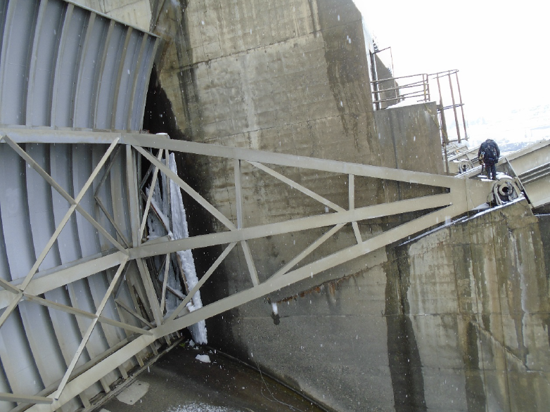
Figure 2-7: Radial Tainter Gate End Frame
There has been anecdotal concern regarding the anchorage of the gates to the piers due to visible corrosion staining emanating from cracks on the concrete piers (see Figure 2-7). The cracks roughly parallel the location of the embedded anchors, and run the entire length of the anchor embedment. The cause of the staining is not known. From the face of the concrete to the twin 3”x7”anchors bars, there is normal pier confinement steel rebar and confinement reinforcement for the cork mastic wrapped embedded trunnion anchors. Since the staining could possibly be a result of corrosion of the embedded steel anchors, there has been some concern regarding potential section loss of these anchors over time. This concern was investigated as a potential consequence for this report. The investigation concluded that neither the visible staining nor cracks are a cause for concern regarding the capacity of these anchors and therefore do not need to be included in the Major Rehabilitation Report. The rationale for exclusion include:
- There are several dams with this exact anchorage design, including at Cougar and Hills Creek Dams. Due to construction practices of the day, the pier concrete likely cured unevenly around the embedded anchors closest to the edge of the pier concrete. The outermost edge of the steel anchor may have acted like a heat sink during the curing process causing the heat of hydration to bleed off into the anchor and cool the area faster that the surrounding mass placement. This condition was made more likely given the large size of the steel relative to the concrete edge distance, which would have compounded the temperature differential effects between concrete and steel during the concrete curing process. The steel trunnion anchors have a cross-sectional area of 42 square inches, with an edge distance of 6 inches; it is likely this large steel area would have caused the thermal cracking in observed in the concrete near the anchors. As such, a typical visible crack developed which can be seen on every single pier face. It is believed that moisture from spill, spray, and rain made its way into the cracks and caused the confinement reinforcement to rust and bleed out of the cracks as seen in photos.

- Regardless of root cause, corrosion can be a significant concern should it be significant enough to cause critical section loss in the steel. However, at the locations noted above, there is only a minor amount of visible corrosion staining. Relative to the large size of steel anchorage members present, a very large amount of corrosion staining would need to be present, in addition to concrete spalling to be considered concerning. Since steel expands in volume around 4-6 times when it corrodes, spalling of concrete is a typical condition associated with significant steel section loss for embedded steel elements. Given the large size of the anchors present, any significant section loss large enough to cause concern would be immediately obvious due to spalled concrete sections. Since this condition is notably absent, it can be assumed there is not a concerning amount of section loss of the steel anchors. Analysis of anchor section loss was performed. The analysis showed that the anchor would have to lose 65% of its cross-section for it to fail in tension with normal hydrostatic loads on the gate’s skin plate.
The Tainter gates are overall in satisfactory condition. Typical deficiencies include localized corrosion, poor weld profiles, corroded lifting and holding anchors, inadequate drainage, and cracking in the concrete at the piers. Various small deformations exist at end frame members, ribs, and girders. Additionally, some end frame top struts exhibit misalignment at the field splice.

Tainter Gate Mechanical Service Disruptions
The spillway gate wire ropes and hoist drums for gates 1-9 were replaced in 2006. The hoist drums have had operating problems since installation. The drum design allows the rope separator place to move axially on the drum. This allows the rope slot dimension to change which has led to inconsistent clearances for the hoist ropes. The most severe problem that has been encountered has been pinching (between separator plates) of the ropes as the gates are operated. This will lead to accelerated abrasive rope wear and will ultimately have an impact on the service life.
The ropes on gates 10 through 23 are original. The original wire rope gate connection design did not provide features that allow rope tensions to be adjusted. The wire rope on gates 10 through 23 have varying amounts of imbalanced tensions between sides of the gate and between individual ropes. The current condition of the ropes and inability to re-tension increase the possibility that the gates will experience imbalanced hoisting loads which would have a tendency to rack and jam a gate during operation. In addition, imbalanced tensions between individual ropes increases the chances that individual ropes would be overloaded during normal operation. The condition of rope tensions has currently resulted in a number of gates (10, 11, 13) being caution tagged.

Spillway Bridges Load Ratings
Bridge Inspections are performed on 2 year intervals as required as part of the Portland District bridge inspection program. The underside of the girders were inspected in 2016. The results of which showed significant diagonal cracking at a number of joints, transverse hairline to medium sized cracks at middle and third points along the bottom and sides of the CIP box and girders, significant spalling along the wall and ceiling at piers 13, 15, 16, and 20, and significant hairline to medium transverse cracks along the floor and vertical and diagonal cracks on the walls of the box girder gallery floor and walls. Major recommendations were to repair deck joints, to develop a repair plan for diagonal cracking at the joints, and continue to monitor existing cracks in the deck, superstructure, and substructure.
Also in September 2016, a design and legal load rating was performed by Kansas City District. The major finding was that the bridge does not meet criteria for the design loads (HL-93) but does meet criteria for legal loads for both routine and special hauling vehicles. The controlling mode of failure is shear for the upstream and downstream girders. Based on the latest bridge load ratings, the bridge does not meet criteria for AASHTO design inventory loads; however, the bridge does meet criteria for AASHTO design operating loads and legal loads. The removable access panel controls with an inventory rating factor of 0.78 and an operating factor of 1.01. No restrictive load posting was considered necessary for the spillway bridge. Given the results of the load ratings, failure of the bridge is not considered to be a direct failure mechanism that needs to be addressed as part of this Major Rehabilitation Report based on normal loading conditions.
The possibility exists the bridge may need to support potential construction/emergency operations for other failure mechanisms considered by this Report. In order to ensure the bridge would not restrict any gate repair operations, the bridge was analyzed as part of the Major Rehabilitation Report to consider assumed construction loading conditions for an assumed gate repair operation. Based on the results of this analysis, which was based significantly on recent repair calculations done for the gate repairs performed at Hills Creek Dam, it was determined the bridge can adequate support gate repair construction loads. The gates at The Dalles and Hills Creek are identical, and the picks are assumed to be approximately the same.

Spillway Uplift Investigation
Twelve uplift pressure gauges were installed during initial construction in the grouting and drainage gallery of blocks 1, 5, 10, 14, 18, and 22. Single gauges were installed directly below the grouting and drainage gallery at blocks 1, 5, 10, and 18. Four Gauges were installed at blocks 14 and 22 to monitor uplift pressure profile. Location of the uplift gauges is shown in the figure below.
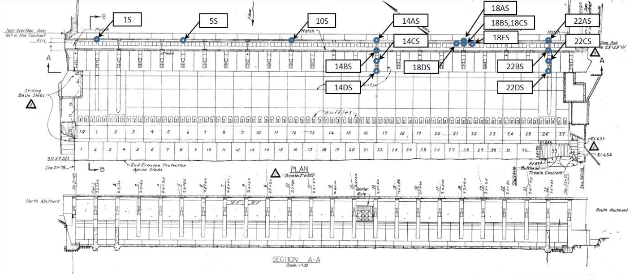
Figure 2-8: Spillway Uplift Gauge Locations (Source: DDD-1-4-2/1. PIR No. 1, and PIR No. 2)
Uplift Pressures at 18A exceeded design uplift starting in 1968, and continued during 1969-1970 and did not drop as in previous years. In May 1971, two test holes were drilled from within the grout and drainage gallery to determine uplift pressures downstream of uplift Gauge 18A. In April 1973, two additional uplift piezometer holes, 18D and 18E, were drilled in Block 18 to determine lateral extent of uplift pressures. Investigations concluded that Block 18 high uplift pressures appeared to be localized near the heel of the dam and did not extend over the full base of the block. Gauge 18 still records uplift pressures greater than design. No movement or offset between the monoliths has been noted. Spillway stability is acceptable and will not receive further consideration in this report.

Spillway Apron Erosion and Undercutting

Summary
This section discusses the potential need for repairs due to downstream erosion along the 8/9 spillwall and the spillway protection apron and the potential for continued erosion in these regions. The currently available data suggests that spillway apron undercutting may be occurring at slow rates, if at all, under the flows of the past 12 years and erosion beneath the 8/9 wall has not been identified as a significant problem. Undercutting measurements are available beginning in 2004. Since then, various measurements are available from 2006, 2007, 2011, 2013 and 2018. A table of reference documents reviewed is given in Table 2-2. The undercut measurements from these reports have been recorded and reported in a somewhat different manner from each other, which does not allow for direct comparison. Survey methods included probing by divers and various sonar surveying techniques. Based on the available data, no section of the spillway apron or 8/9 wall segments appear to be experiencing large increases to undercutting or existing erosional features and immediate repairs are not necessary. The most significant erosional features are found under the spillway apron downstream of Bays 9, 22 and 23. Repairs to the most significant erosional features under the spillway apron downstream of Bays 9, 22 and 23 could be done by drilling through the apron and pumping tremie grout into the void space, contained by temporary forms where necessary. The most significant concrete spalling/erosion are identified in the concrete of Bay 1 and could be repaired by saw cutting, preparing and replacing removed concrete.
DOCUMENT REVIEWED | DATE ISSUED
2002 Spillwall Dive Video | 1-Dec-02
The Dalles Dam and Reservoir Spillway Modification (6/7 wall drawings) | 18-Jun-03
The Dalles Spillway Improvement Study | 1-Jul-04
Erosion and Undercutting Schematic | Fall 2006
MFR - The Dalles Lock and Dam 2006 Spillway Erosion Results | Fall 2006
The Dalles Bay 8/9 Spillwall - Dive Report | 31-Oct-07
The Dalles Lock and Dam Spillway Bay 8/9 Spillwall 8/9 - As-Builts | 16-Mar-09
Apron Undercut Fill - Segment 6 | 30-Nov-09
MFEC - The Dalles Dam 2010 Dive Survey 8/9 Spillwall, Apron Undercut | 15-Sep-10
Section 12 - Post Construction 8/9 Spill Wall
The Dalles 8/9 Spillwall 2011 Dive Survey | 6-Oct-11
The Dalles Dam Spillwall - 2013 Erosion Surveillance | 17-Sep-13
The Dalles 8/9 Spillwall 2013 Dive Survey | 17-Sep-13
2018 The Dalles Dam Spillway Stilling Basin ROV Inspection Report | 11-Dec-18
Table 2-2: Reference Table for Spillway Apron and Wing Wall Erosion

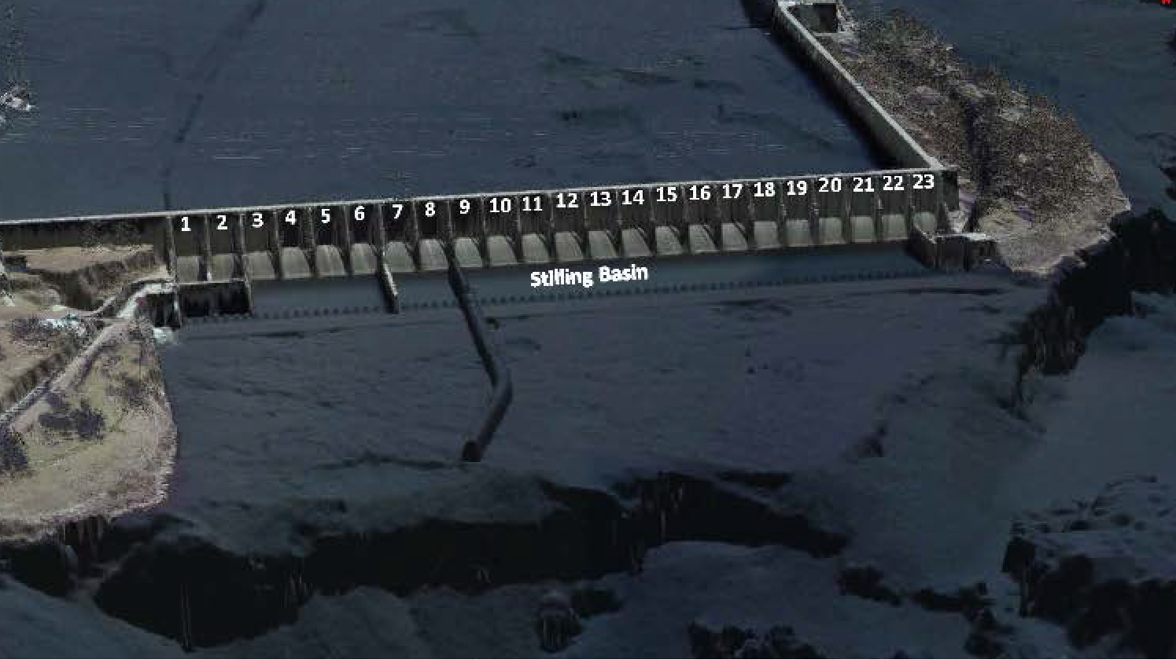
Spillway Protection Apron
6/7 Spillwall
8/9 Spillwall
Areas Surveyed for Erosion
Largest Undercut beneath apron downstream of Bays 22 and 23
Figure 2-9: General Overview of Spillway and Training Wall Areas Surveyed for Erosion

Spillway Protection Apron Undercutting Erosion
Undercutting has occurred along the entire length of the spillway apron and currently ranges between <1 feet and 25. Undercutting ranges between <1 feet and 8 feet downstream of Bays 1 through 21 with a maximum undercut of between 4 feet and 8 feet downstream of Bays 3-5 and 9. Available data suggests that undercutting could be as great as 20 feet to 25 feet downstream of Bay 23. Gate 23 is tagged out due to the excessive undercutting of the apron downstream of Bay 23.
Interpretation of the available documents discussing and recording undercutting values of the spillway protection apron suggest minor changes occurring year to year. A significant trend of increasing undercut is not apparent within the data and changes identified may be within the error tolerance of the data collection technique. There is a discrepancy with the 2011 report that notes 15 feet of spillway apron undercut at Bay 9. The 2018 and 2013 ROV inspection and dive survey suggest undercutting in this area on the order of 6 feet, similar to nearby values recorded in 2004 and 2006. At Bay 23, the 2006 and 2018 documents state the undercutting was ranging from 17' to 20', suggesting a relatively slow or non-existent rate of undercut advancement. However, the 2018 report has discrepancies with regards to the extent of the undercutting. Values in the report range from 17' to 25' of undercut at Bay 23. Depending on which is correct in the 2018 report, there may be 0 feet to 7 feet of new undercut since 2006 at Bay 23. Due to the difficult nature of recording the undercut at Bay 23, a determination cannot be made because the measurement error could account for the difference.

8/9 Spillwall Erosion
Spillway apron undercutting features north and south of the 8/9 spillwall were measured and repaired during the spillwall construction in 2009 and 2010. The repair was achieved by filling the undercut with grout. Subsequent surveys report that the grout has remained in place in the north repair but has been scoured out of the south repair, beneath spillway protection apron downstream of Bay 9. To date, it does not appear that the erosion beneath Bay 9 has significantly increased and does not immediately threaten stability of the spillway apron or the 8/9 spillwall. There is a known discrepancy between the 2011 dive survey and the 2013 erosion analysis, which list 15 feet and 6 feet of undercut south of the 8/9 spillwall, respectively. This discrepancy is attributed to measurement methods and scope interpretations during each dive survey, according to the 2013 erosion analysis report and the 2018 erosion analysis has recorded measurements similar to those reported in the 2013 documentation.
There is no data suggesting the leveling pad or spillwall foundation has been undercut by erosion. Some areas of erosion directly adjacent to the wall along its alignment have been noted in the field reports from various surveys conducted but none suggest potential instability. A significant erosion feature is noted adjacent to the 8/9 spillwall and in contact with the spillway apron at Bay 9. This feature does not appear to have grown significantly since being identified but because of its proximity to both the spillway apron and wing wall foundation, it must be monitored and should be repaired if found to be expanding. Downstream of the end of the 8/9 spillwall (Segment 15), a difference in the surface elevation is noted between recorded surfaces before and after wall construction. Changes in this area between 2011 and 2013 (both post wall construction) appear to be negligible. Surveys conducted after 2013 have not been plotted with the 2011 and 2013 surfaces but areas of major concern from the 2018 survey have not been identified. The surface elevation downstream of the end of the wall appears to have stabilized under the flows since construction in 2010. This is further confirmed by Figure 2-10 below, which shows the comparison of the 2018 hydrosurvey with the previous surveys.
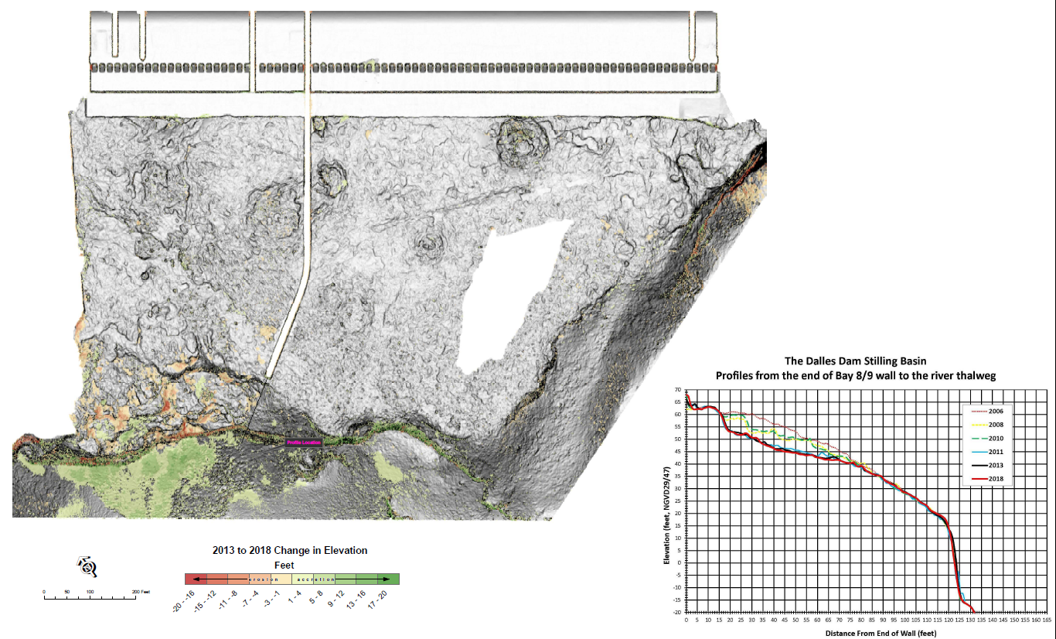
Figure 2-10: 2018 Bathymetry Comparison with 2013 and Previous

Continued Monitoring and Repairs
Continued erosion monitoring is recommended along the entire length of the spillway protection apron and the 8/9 spillwall. The previous documentation suggests repairs should be performed when spillway apron undercuts have progressed beyond 18 feet laterally (upstream from the downstream end of the wall) under the concrete. The spillway apron downstream of Bays 22 and Bay 23 is shown to have undercutting greater than 18 feet and should be repaired. Although no hydro or dive surveys identified other deficiencies needing immediate repairs, erosional features that could progress into significant problems in the future have been identified. The spillway apron undercut documented south of the 8/9 spillwall, downstream of Bay 9, was unsuccessfully repaired during the construction of the wall in 2010. This area should be monitored for expansion of the undercut. Various concrete erosion has also been documented in the previous reports, especially near joints and at interfaces downstream of Bays 1 through 8 and along the 8/9 spillwall segments. The repair of concrete erosion in Bay 1 is recommended. See Figure 2-11 for approximate region of Bay 1 concrete erosion (reported to be concentrated near construction joints).
Typically, all repairs of erosion occurring in the native basalt or weak rock subgrade can be accomplished by tremie grouting after proper surface preparation. The rock surface needs to be cleaned and prepared before receiving grout. To repair the erosional features beneath the spillway apron, a containment (wall) would need to be placed at the end of the apron and holes drilled through the spillway apron concrete. Grout could then be tremied into place and contained by the wall. The entire void space must be filled and good contact to both the prepared rock surface and the apron concrete is required. Concrete erosion can be repaired by saw-cutting clean lines and preparing the surface to receive new concrete. After proper preparation, new concrete can be placed to match the existing concrete surfaces.

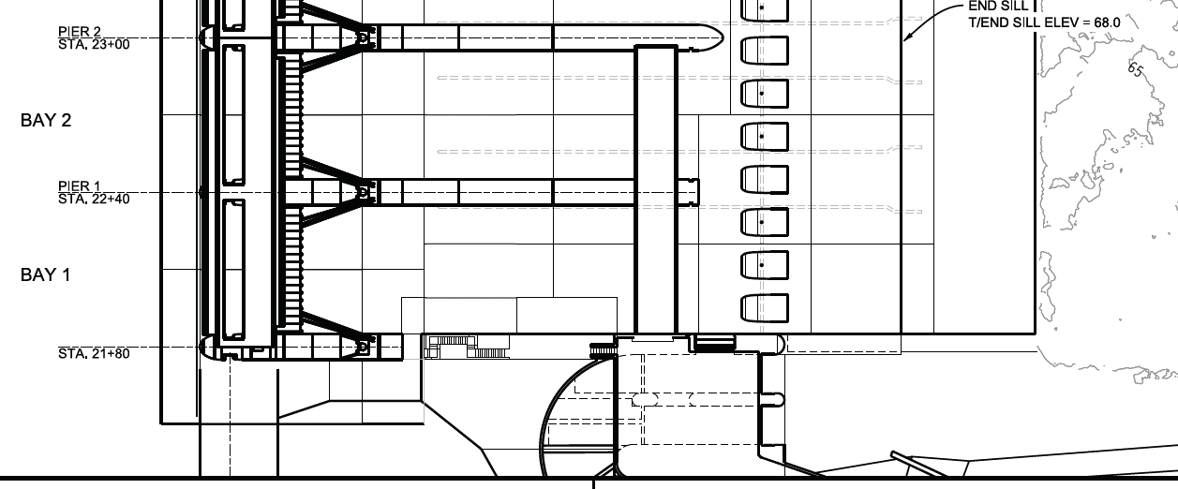
Construction Joint
Figure 2-11: Approximate Region of Concrete Erosion in Bay 1 (Erosion Concentrated Around Construction Joints)

Navigation Lock Filling and Emptying Valve Repairs and Replacement
The original Navigation Lock Tainter valves were built and installed around 1955. The lock started operations in 1957. By 2008 it was estimated that each valve experienced up to 122,850 load cycles. These valves underwent significant field repairs over the 50 years of operation. There is limited field information available, however the project inspected and made repairs to the Tainter valves as necessary.
By 2008, the navigation lock had two valves out of service, valves number 1 (north emptying) and number 3 (north filling) were not in service. This left only the south filling/emptying culvert in service with valves number 2 (south emptying) and number 4 (south filling). Using a single culvert roughly doubles the filling/emptying time for lockages. Inspections and investigations concluded that steel cracking was due to excessive vibrations; and that crack repair, re-welding, and adding stiffeners would only redistribute the stress to other locations of the Tainter valves which would not extend the valve service life. Because of the concern for reliability and potential lock shutdown, it was determined that the valves were at the end of their service life and were replaced in 2011.
Changes in the original valve design included using A709 structural steel and AWS D1.5 weld criteria, installation of greaseless trunnion bushings, changes to the cover plates to eliminate high fatigue category E welds, and changes to member sizes and connection details.
Almost immediately after installation in 2011, the trunnion pin keeper plates were rotating and breaking bolts. Because of this, several alternative keeper plates and bolt arrangements were tested with a final arrangement that has been implemented on Tainter Valve #1 in 2015, and Tainter Valve #3 in 2016. Also following installation in 2011, cracking on the skin plate of the valves at the ends of the upper beam has occurred which has required welding of additional stiffeners along the web and flanges, for the two upstream valves (Tainter Valves #3 and #4). To limit pressure differential on the culvert conduit walls, a pressure indicator was installed in 2017, which monitors the pressure between the Tainter valve shaft and navigation lock, to allow an adjustment of the opening speed of the Tainter valve based on the maximum differential pressure of 18 feet (this limit is based on a report dated 20 Sep 69). This allows the Tainter valve to open faster at the beginning of the lock filling operations, then open slower towards the middle and end of the cycle to optimize lock operation.
There is an ongoing project to verify the cause of the cracking and determine a final repair to address the cracking issue.

Navigation Lock Downstream Miter Gate Replacement
Due to the extensive nature of cracking identified in the original miter gate during the 2009 emergency lock outage, the district recognized the intended repair plan to replace only the quoin and miter blocks along the bottom girder web would not sufficiently restore the gate to reliable service. In November 2009, formal design of a replacement gate was initiated. In order to give the fabricator sufficient time to construct the gate, the designers were given less than two months to complete plans and specifications. A contract to fabricate and install the new gate was awarded in January 2010.
The new gate was designed with proper detailing for fatigue including proper radii at weld transitions, increased weld quality and testing, adjustable miter and quoin blocks, adjustable diagonals, and self-lubricating pintle. In addition to adjustable miter and quoin blocks to prevent a lack of contact with subsequent erosion and cracking, the pintle and bottom portion of the gate was designed to resist the load created by a loss of quoin post contact at the bottom six girders. Targeted permanent instrumentation was installed on the new gate to permit future monitoring and confirmation of design stresses.
The new gate installation was occurred during the extended lock outage starting December 2010 with the gate going into operation in April 2011.
In 2017 the embedded gudgeon anchor was replaced to ensure a 100 year fatigue design life in accordance with ETL 1110-2-584 “Design of Hydraulic Steel Structures”. The new gudgeon anchor was designed with exposed elements to permit inspection. In addition to a new gudgeon anchor, an impressed current corrosion protection system was installed.
The new navigation lock miter gate at The Dalles Dam has performed well since installation in 2011. The incorporation of instrumentation into the new gate will permit District engineers to continue to monitor the structures performance between lock outages. The improved detailing and incorporation of adjustable components has resulted in excellent performance to date with no known deficiencies. Lessons learned from the design and fabrication have been transferred to several new gates being designed and fabricated throughout USACE.

Navigation Lock Upstream Radial Gate Replacement
The original upstream navigation radial lock gate measured 23-feet 5 inches in height and 91-feet in width. The strut arms, horizontal trusses, and miscellaneous bracing were constructed of Fed Spec QQ-S-741, Type II carbon steel. The gate was fabricated by the Atkinson Ostrander Company and installed in-place in the mid 1950’s (Figure 2.45). The gate is raised and lowered using wire ropes.
The original gate underwent numerous repairs resulting from barge impact damage and normal service. The original gate was in service from 1957 to 2016, and had experienced approximately 187,000 cycles. Due to the age of the gate, prolific cracking and the likelihood of continued cracking, it was decided to replace the upstream gate.
The new gate was fabricated by Greenberry Industrial, Vancouver, Washington. The gate was barged upriver to the site and ultimately installed by the general contractor, Northbank Civil and Marine on January 31, 2017.

Historical Repair Costs
The tables below summarize costs categorized by the significant project features for normal and emergency activities. While they do not provide an all-inclusive display of all maintenance, they do indicate an increase in the number and magnitude of major contract repairs of the past 20 years.
Navigation Lock
Year | Item Repaired | Cost
2008 | Miter Gate Emergency Repair | $1,553,868
2010 | Miter Gate Replacement | $34,476,024
2011 | Tainter Valve Replacement | $2,284,695
2014 | DW Approach Shoaling- Dredging | $154,936
2015 | TD NAVLOCK main switchgear LCQ Replacement (supply) | $4,310,043
2016 | NAVLOCK US Gate, Controls, Gudgeon – Auto PLC Sys | $12,403,592
Table 3: Historical Repairs to the Navigation Lock at The Dalles.
Spillway
Year | Item Repaired | Cost
2001 | Spillway Gantry Crane Refurbishment – Task order No. 0002 (P&S) | $247,775
2003 | Spillway Modification—prototype trunnion lubrication sys. | $9,628,324
2004 | Training wall Bays 6-7 | $1,961,700
2004 | Spillway Bay 1 Erosion Repair | $153,000
2005 | Spillway Gate Bay 1-9 Wire Rope Replacement | $180,850
2007 | Baffle Block Closure Device
2010 | Training wall Bays 8-9 | $56,496,909
2011 | Downstream Gate Gearbox | $940,685
Table 4: Historical Repairs to the Spillway at The Dalles.
Powerhouse
Year | Item Repaired | Cost
1997 | Exciters Units 15-22 | 1,688,102
1997 | Station Service Switchgear (SQO)
1997 | Powerhouse Bridge Crane Rehab | $3,196,070
2000 | Generator Rewinds and Rehab | $10,196,394
2000 | Intake roller gates and draft Tube Stoplogs (P&S) | $4,056,000
2000 | Station Service Generator Units 1 and 2 Governor Upgrade | $9,543,000
2001 | Station Service Generators Static Exciters | $424,736
2002 | DC Systems Upgrade (batteries, Chargers) | $6,657,089
2002 | SF6 Circuit Breakers | $11,912,853
2003 | Emergency Intake Gantry Crane Rehab | $5,548,050
2003 | Intake Gate Repair | $207,568
2003 | Oil Water Separator System | $2,560,810
2004 | Gross Head Sensing Improvements | $450,944
2005 | Rehab of 100T intake Gantry Crane (Hammerhead) | $5,872,098
2005 | Transformer T2 Replacement | $4,057,394
2005 | Synchronous condensing compressed Air System (Plus Top Plate Pumps) | $4,670,612
2006 | HVAC Improvements (HP3) | $7,232,132
2007 | Disconnect Switch and Surge Arrestor Replacement | $3,018,177
2007 | Transformer T4 Replacement | $8,617,298
2007 | Restroom/Locker Room | $358,403
2008 | SS Improvements | $22,870,048
2009 | Fish Units Governor Replacement Equipment | $29,622
2009 | Transformer Fall Protection | $857,041
2010 | Digital Governor installation | $13,711,979
2011 | Powerhouse Roof Replacement | $5,968,725
2011 | Turbine Blade Seals | $75,180
2012 | Elevator Rehab (West, East, Station Service) | $3,826,508
2012 | Oil Water Separator (3rd) | $64,510
2013 | Fire Protection and Control Room Pressurization | $7,010,854
2014 | Tailrace Gantry Crane Rehab | $4,800,556
2015 | Refurbish Turbine Bearing – Main unites 15-22 | $96,004
2015 | Gen II Vacuum Dehydrator | $179,858
2016 | Oil Switch Replacement- DQ3 and DQ4 | $398,924
2016 | Head Cover Repairs | $1,072,097
2017 | Fish Unit Breaker Replacement | $4,645,677
2017 | Trust Bearing Oil Coolers (U1-14) | $183,189
2017 | Generator Air Coolers – Main Units 15-22 | $178,897
2017 | Elevator Rehab – Bay 15 | $1,338,921
2017 | SR (Lighting Substation) Panel Replacement | $3,367,132
2017 | Railroad Track Removal and Deck repair | $2,606,138
2017 | GSU Transformer Replacement | $18,090,515
2017 | SCC Control Replacement | $751,739
2018 | Turbine Maintenance Platforms | $343,959
2018 | U21 Exciter | $167,105
Table 5: Historical Repairs to the Powerhouse at The Dalles
Non-overflow Dams
Year | Item Repaired | Cost
2010 | Pavement – Admin and Tailrace Approach Road | $109,826
Table 6: Historical Repairs to the Non-overflow Dams at The Dalles
Fishways
Year | Item Repaired | Cost
2002 | North Fishway N3 Concrete Wall | $548,897
2002 | The Dalles Fishway Dewatering Improvements
2011 | Fishway Grating | $132,738
2015 | East Fish Ladder Auxiliary Water Supply (AWS) Backup | $36,272,778
2017 | East Fishway MCC FCQ7 Replacement | $228,089
Table 7: Historical Repairs to the Fishways at The Dalles.
MISC. - 2005, Celilo Levee Pump House Replacement, $87,159

Routine Maintenance Costs
Routine Annual operations and maintenance costs (O&M) include the costs for continual (24/7) operations of The Dalles Lock and Dam. Routine Maintenance includes the minimum amount of maintenance that is require to allow to function until funding from the next budget cycle becomes available, including facility labor, contracting support, This includes a portion of routine facility costs, periodic inspection costs, safety equipment, service and supply contracts necessary for maintenance etc.
Routine O&M Costs
Year | Hydropower | Joint (incl. Spillway) | Fish and Wildlife (incl. fishway) | Navigation
FY 05 | $9,849,995 | $1,332,746 | $786,129 | $735,469
FY 06 | $10,798,868 | $1,621,842 | $842,986 | $671,425
FY 07 | $11,146,047 | $1,957,429 | $1,181,385 | $969,830
FY 08 | $11,378,725 | $2,037,034 | $1,126,567 | $879,138
FY09 | $12,047,068 | $2,020,630 | $845,651 | $969,771
FY 10 | $12,917,427 | $2,494,747 | $1,144,837 | $1,054,359
FY 11 | $12,363,091 | $2,407,698 | $1,352,418 | $1,055,454
FY 12 | $12,567,613 | $2,398,834 | $1,171,807 | $897,741
FY 13 | $12,874,201 | $2,559,141 | $1,076,644 | $960,628
FY 14 | $14,060,151 | $2,317,563 | $1,060,108 | $924,399
FY 15 | $15,517,529 | $2,647,610 | $1,203,517 | $971,427
FY 16 | $15,005,441 | $2,649,959 | $1,204,581 | $1,142,712
FY 17 | $15,853,783 | $2,755,508 | $1,119,908 | $909,538
Table 8: Routine O&M Costs at The Dalles

Periodic Inspection Reports
Periodic inspections occur every five years at The Dalles Dam. Periodic inspection reports are available from 1968 to 2018, and describes the condition of a feature, identifies deficiencies, and provides recommendations for improvement. The latest set of inspection reports are available as references to this document. The project team reviewed these reports to identify any items that should be further considered within the RER.

Operational Condition Assessments (OCAs)
Operational Condition Assessments (OCA) are periodic reviews of all major components and subcomponents at a project site. In an OCA, letter grades (A through F) are assigned to components through performance history/issues by project staff and visual inspection which allow for components to be ranked. The May 2018 OCA report was used to support and help to inform the analysis in the RER. Major features assessed in this OCA included the Navigation Lock, Dam Structure, Dam Gates and Operating Machinery, Primary Utilities Distribution and Controls, Controls, Lock and Dam Bridges, and Emergency Maintenance and Closure System. The project team reviewed the ratings and associated comments for all the components and subsystems of these major features. The team used their knowledge and experience coupled with the OCA ratings to identify components and subsystems to carry forward for further analysis.

Periodic Assessment Report
Periodic Assessment (PA) Report No. 1, dated March 2018, is the most recent report that evaluated the condition of the project. The PA consisted of a facilitated Potential Failure Mode Analysis (PFMA), a Period Inspection (PI), and a risk assessment of the potential failure modes judged to be risk-drivers. A potential failure mode (PFM) is a chain of events leading to dam failure or portion thereof that could lead to dam failure. Periodic inspections are focused inspections on a regular basis as part of a project. The following PFM were identified as being the highest risk drivers for the Project:
PFM CD-01: Seismic liquefaction of upstream sand/gravel foundation and seepage blanket material causes upstream slope failure and overtopping.
PFM PH-03: Powerhouse roof failure due to seismic loading.
PFM SW-03: Failure of the Tainter gate due to trunnion friction
PFM SW-05: Tainter gate failure due to seismic loading
The PA also identified 2 other PFMs, though not considered risk drivers, recommended for further consideration in the Major Rehab: PFM SW 04: Mechanical/Electrical Failure of Tainter Gate Hoist System, PFM SW 06: Spillway Tainter Gate Trunnion Anchorage Failure. The report concluded with the recommendation to change the Dam Safety Action Classification (DSAC) from DSAC 3 to a DSAC 4. For additional details, see the complete periodic assessment report provided as a reference to the RER.

Geotechnical Analysis

Seismic Safety Review (SSR)
A Seismic Safety Review was completed in 2013, in accordance with ER 1110-2-1806, “Earthquake Design and Evaluation for Civil Works Projects,” dated 31 July 1995. The main purpose of the Seismic Safety Review (SSR) was to reevaluate the seismic safety of the dam given the recent advances in the understanding of the seismicity of the region, which have resulted in a significant increase in the expected seismic motions at the dam site. Seismic analysis for the spillway indicates that the spillway monoliths are considered to be stable. However, the spillway piers will likely be subjected to significant levels of force/stress during a Maximum Credible Earthquake. Spillway features, such as the spillway piers and gate structures, can be damaged during a seismic event, which can lead to uncontrolled loss of pool. The study recommended additional analysis. To review the complete seismic analysis, see the SSR which is provided as a reference to the RER.

Site-Specific Seismic Hazard Analysis
A modern site-specific probabilistic seismic hazard analyses (PSHA) and deterministic seismic hazard analyses was completed for the Lower Columbia River Dams which includes The Dalles Dam. The report titled: “Site-Specific Seismic Hazard Analyses of Lower Columbia River Dams”, dated 26 January 2018 is on file at ETDS:

\Misc_Resources\Dam_Safety_Routine_Tasks\Seismic\Lower_Columbia_Report_and_Figures\
Final Report\Lower Columbia Final_012618.pdf.
The study estimated foundation seismic conditions and developed seismic hazard curves, response spectra and spectra compatible time histories that will be necessary for future structural analyses for the dam. The site-specific results show the peak ground accelerations are about 30% higher for the return periods of interest. However, the response spectra is predicted to be lower about 10% and 25% lower at response periods of 0.2 and 1 second. The results and conclusions of previous analyses completed for the SSR are still valid.

Rock Anchor Test Program
The objective of the work (the proposed training wall would be an extension of the spillway pier) was to design and conduct a rock anchor testing program to determine a range of design values for rock/grout bond shear strengths in the basalt bedrock to allow for the determination of the anchor embedment length for future rock anchors. The “Geotechnical Data Report: Rock Anchor Test Program” is available reference to this document.

Identification of Problems and Opportunities
The main deficiencies at The Dalles Lock and Dam spillway include:
- A vast majority of the major operating systems and components have greatly exceeded their design life. Some components perform poorly and others are showing signs of unreliability which can have economic and life safety consequences as well as environmental and fish passage consequences.
- The primary consequences are unplanned outages due to loss of pool, unexpected maintenance/replacement costs or procurement timelines that would extend an outage, and environmental impacts including potential challenges in meeting ESA related fish passage requirements.
The main opportunities of the RER for The Dalles Lock and Dam include:
- Identifying the most efficient strategy for major component repairs.
- Improve the operational reliability of The Dalles Spillway.
- Reduce the risk of unscheduled closures or outages due to structural, mechanical, or electrical failures.
Currently, the most likely future condition of The Dalles is a “fix-as-fails” maintenance strategy. This means that as a component breaks or fails it is repaired or replaced as quickly as practicable to restore service. This strategy has inherent risks which could shut down turbines or the navigation lock for an extended period of time as well as subsequently impact environmental and fish passage requirements. The purpose of the RER is to examine a component’s condition and performance, degradation rate, failure consequences, and repair strategies to understand if a “fix-as-fails” maintenance strategy is acceptable or if investment prior to failure is a better economical choice.
The specific study objectives, as identified in EP 1130-2-500, include:
- Establish the overall engineering condition and reliability of the project and all major project features (See Section 4)
- Identify and define the operational and/or potential reliability problems (See Section 4)
- Identify Alternatives (See Section 3.2)
- Develop cost estimates for the proposed solution (See Appendix D – Cost)
- Determine if the proposed projects are eligible for funding under the major rehabilitation program (See Section 8)
- Estimate the total economic cost and benefits of the base condition and alternative solutions (See Appendix B – Economics)
- Identify all environmental concerns and complete all environmental reporting requirements (Se Section 6)
- Identify the recommended plan (See Section 7)
- Develop a M-CASES cost estimate for the recommended plan (See Section 9)
- Prepare a Project Management Plan (See Appendix E)

Component Identification, Screening, and Selection
Key points in the component identification and screen process started with the Screening Portfolio Risk Assessment (SPRA) in 2007, which assessed The Dalles with a Dam Safety Action Classification (DSAC) of 3 or “moderately urgent”. The DSAC classification scale ranks USACE dams on a scale of 1 to 5 with DSAC 1 representing “dams where incremental risk - combination of life or economic consequences with likelihood of failure - is very high” and DSAC 5 representing dams with very low incremental risk. This initial classification did not take any economic consideration of service disruptions into account.
The primary reasons for the DSAC 3 rating were structural reliability of the spillway gates, structural capacity of the spillway piers, structural/electrical/mechanical reliability of the navigation lock gates, internal stability of the concrete structures, stilling basin scour, emergency crane and power systems, rockfill closure dam seepage and piping, and rockfill closure dam stability and liquefaction. Based on the results of the 2018 Periodic Risk Assessment, the estimated total incremental risk has decreased, and the Periodic Assessment (PA) team recommends that the dam be reclassified as DSAC 4.
Three potential failure modes identified in the Periodic Assessments will be carried forward for evaluation in the RER and those include:
PFM SW-03: failure of Tainter gate due to trunnion friction
PFM SW-04: Mechanical/Electrical failure of Tainter gate hoist system
PFM SW-06: Spillway trunnion anchorage failure
PFM CD-01: Seismic liquefaction of upstream sand/gravel foundation and seepage blanket material causes upstream slope failure and overtopping and PFM PH-03: Powerhouse roof failure due to seismic loading are not being considered by this MRER due to their seismic initiation processes. Major Rehabilitation and Evaluation Reports do include potential failure modes that are initiated by a seismic event. The report focuses on failure risks associated with normal operations and loadings. An informal, iterative, screening process was utilized by the Project Team in April 2018 to examine the components within The Dalles to determine which components would be carried forward for full evaluation within the RER.
Item No. | Location | Description | Discussion | Status within RER (2018)
1 | Spillway | Trunnion System | Trunnion components including pins, yokes, beams, and pier anchorage. Trunnion friction already suspected for overstressing Gate end frames and Gate 9 is tagged out due to seized trunnion pin. Failure of the trunnion system could impact the ability to control flow and failure of Gates 1-8 could impact fisheries. PFMs SW-03 and SW-06. | Yes, include in RER
2 | Spillway | Gate End Frames | HSS inspections noted a number of deflections end frames members which have resulted in gates 16, 18, and 19 to be tagged out of service by the project. Recommended for inclusion in the RER due to possible end frame overstress. Failure of the gate end frames could result in the inability to operate the gate and control flow. PFM SW-03 | Yes, include in RER
3 | Spillway | Mechanical Equipment | Numerous broken wires have been observed and have caused gates 10, 11 and 13 to be tagged out of service. Wire ropes are a component of the Mechanical Equipment. Recommended for inclusion in the RER due to current degraded condition. PFM SW-04 | Yes, include in RER
4 | Spillway | Electrical Equipment | The entire electrical distribution system from the 4160V feeders and DQ1/DQ2 substations, down to the spillway gate control panels, are all original equipment from the 1950’s installation. DQ3/DQ4 oil switches are failing and a potential fire hazard. All of the electrical equipment is operating beyond their design life and significant problems are expected as the equipment ages further. Loss of power could potentially inhibit the ability to actuate gates. PFM SW-04 | Yes, include in RER
5 | Spillway | Controls | The spillway controls will have collateral damage to the mechanical and electrical equipment. Loss of electrical control could inhibit the ability operate the gates. Because there are both centralized and localized controls, there is less risk of losing the ability to control a gate. PFM SW-04 | Yes, include in RER
6 | Spillway | Apron | Gate 23 has been tagged out due to scouring that appears to exist in the apron at Spillway Bay 23. An ROV inspection will occur to determine whether scouring occurred as a result of spillway operations or if this location was used for a sump during construction of the spillway. Scour could compromise the spillway which could impact stability. | Yes, include in RER
7 | Spillway | Bridges | It is suspected that the shear capacity of the spillway bridges is exceeded by the current project crane. If the spillway gantry crane malfunctions, the deck will not be able to support a mobile crane necessary to install to place stop logs. | Yes, include in RER
8 | Spillway | Gantry Crane Mechanical | Failure of the spillway gantry crane would eliminate or reduce the ability to install stop logs for maintenance operations. | Yes, include in RER
9 | Spillway | Gantry Crane Controls | The gantry crane controls are obsolete and operating beyond their design life. The control system is not expected to operate without significant problems as the equipment ages further. Replacement parts are difficult to find since the original parts manufacturers no longer support most of the control equipment. | Yes, include in RER
10 | Navigation Lock | Drain Valve Pit Wall | This wall is under reinforced and differential loading could cause wall failure. Currently, this is automatically controlled by changing the rate of valve operation due to reading from pressure sensors but a failure of these components could result in excessive head differential. Failure could inhibit navigation operations through the lock. | Screened out
11 | Navigation Lock | Tainter Valves | Ongoing issues with Tainter valve trunnions and keeper plates. Portland District is currently analyzing the Tainter Valves to make them more reliable (DDR). Failure could inhibit navigation operations through the lock. | Screened out
12 | Utilities | Power Distribution | Primary Utilities Distribution and Controls included in the RER due to low OCA rating. Loss of power could potentially inhibit the ability to actuate gates. | Yes, include in RER
13 | PH | 10-Minute Closure, Powerhouse Emergency Gantry Crane | Current Emergency Gantry Crane cannot close the gates in the required 10-minute time period. There is a risk that it may not be possible to close emergency intake gates in 10 minutes causing flooding to the powerhouse and damage to the turbines and equipment. | Screened out
14 |  | Water System | Potable water system head tank is not physically secure from tampering as required by State Law. If the system shuts down, cooling water will be drawn from the river until the system is repairs. | Screened out
15 | Rockfill Closure Dam | Rockfill Closure Dam | The rockfill closure dam is performing as expected with no seepage issues. The Period Assessment at The Dalles identified that an extreme seismic event could cause a failure in the rockfill closure dam but since the seismic event has such a low probability, repairs to the closure dam were not carried forward in the Major Rehabilitation. | Screened out
16 |  | Septic System | The septic system is active state of failure. Previous issues include a sewage leak into the fish ladder which required a partial shutdown of the system and a sinkhole appeared after line break. The line break caused temporary shutdown of the sanitary facilities and required portable toilets. The Septic System should be repair or maintained out of Operations and Maintenance funds and will not be included in the Major Rehabilitation Report. | Screened out
17 |  | Westrick Building | The Westrick Building is the Northwestern Division’s Emergency Operation Headquarters. The Westrick Building has roof and power issues that do not pose a threat to the major facilities operations. The Westrick Building issues should be funded with Emergency Operations Funding and will not be incorporated into the Major Rehabilitation. | Screened out
18 |  | Access Bridge | Approaches of the Access Bridge over the rail road tracks have been identified as an issue at The Dalles. Since the access bridge has an acceptable bridge rating, the Major Rehab team recommends investigating the settlement and repairing with Operations and Maintenance funds. The issues do not pose a serious threat to major dam operations and will not be carried forward in the Major Rehab Report. | Screened out
19 |  | Service Building | During the screening process, it was noted that there are significant issues with the roof of the Service (Administration) building. The Service building should be investigated and repaired if determined as inadequate. Since, the service building poses life safety concerns it should repaired prior to the Major Rehabilitation. This component will not be included in the Major Rehab Report. | Screened out
20 |  | Lock Wall | Minor movement has been identified in the lock walls in a 2010 Survey. The wall anchors have 30’ embedment and are considered stable. The major rehab team recommends monitoring the Lock walls but due to the stable deep embedment and the Navigation Lock Walls will not be included as part of the Major Rehabilitation at The Dalles. | Screened out
21 |  | Fish Ladders | The team identified rock fall issues and leaking joints in the North and East Fish ladders. This non-routine maintenance and was not included in the Major Rehabilitation. | Screened out
22 |  | South Abutment Elevator | Elevator is original. Electrical equipment has been modified to meet current codes. If failure were to occur, there are redundancies (stairs and roadway) so the overall risk is very low. Fix as fails is a satisfactory plan. | Screened out
Table 9: Components considered for detailed analysis in the RER.

Alternative Strategies for Investment
Corps guidance (EP 1130-2-500) requires considerations of the alternative repair strategies listed below for Major Rehabilitation Evaluation Reports. In Section 4 and 5, the final components are evaluated against a baseline without-project condition and compared against the four alternative repair strategies listed below.
• Advance Maintenance strategy consists of expenditures in excess of routine Operation and Maintenance (O&M) funding that reduces the likelihood of some emergency repairs, temporary service losses, and/or the rate of service degradation. Under this scenario, the effect that repair investments have on expected service disruptions and reliability must be evaluated. Not all components lend themselves to this strategy and some components are already in a state of advanced maintenance. This is typically an O&M funded strategy.
• Scheduled Repair strategy assesses the components in terms of service disruption probabilities and consequences. This is an investment in a plan and/or item that reduces consequences given a component failure. Based on this assessment, specific parts could be stockpiled or other preparations undertaken to reduce the service disruption time if the component were to fail. Not all components lend themselves to this strategy. This is typically an O&M funded strategy.
• Immediate Rehabilitation strategy consists of replacing economically-justified components as soon as possible with due consideration of project operations, winter closure periods, general priorities, etc. This is typically a construction general (CG) funded strategy.
• Scheduled Rehabilitation strategy uses the Immediate Rehab strategy as a basis, but requires that the “optimum” rehabilitation time be identified based on the economic costs of the disrupted service. With this strategy, construction contracts can spread out and the full rehabilitation of a project drawn out. This is typically a CG funded strategy.
Several of the components selected to move into the RER went through a detailed reliability (risk) analysis which is outlined in Section 4. A risk analysis of a component examines several items including the probability of failure and the potential consequences associated with failure. Consequences can include: repair costs, system shutdown costs, damage to other components, impacts to navigation through service disruptions, and changes to component reliability. Section 4 of the RER provides detailed risk and reliability information on the final 10 components. Each component was analyzed in Section 4 to determine which maintenance strategies for investments were feasible. For instance, scheduled maintenance did not make sense for every component. Once it was determined which alternative investment strategies were feasible for a component, the strategy was analyzed to determine its economic feasibility. Components that underwent a detailed reliability analysis were analyzed with an Excel-based @Risk model to determine BCR benefits-cost ratio (results presented in Section 5).
Therefore, each of the final 10 components were evaluated against an advanced maintenance, scheduled repair, immediate rehabilitation, or scheduled rehabilitation investment strategy.

Engineering Reliability and Evaluation
This section of the report summarizes the components that the team determined to have the highest potential for inclusion within the recommended plan. The components carried forward into this section for in-depth evaluation and consideration include
- Spillway Structural
- Spillway Mechanical Equipment
- Spillway Controls
- Spillway Power Distribution
Detailed information on each component analysis is contained within the appendices. Each component was evaluated to determine its baseline contribution to risk give a without-project condition. The without-project risk evaluation of each component is an estimate representing a cost of owning and operating aging components. There are likely many potential outcomes, but the analyses herein are considered a reasonable representation of future risks.
To establish the overall engineering condition and reliability of the project and all major project features, the Project Development Team (PDT) identified reliability problems associated with critical project features as well as identified which project features are not unreliable. The PDT analyzed the current and anticipated future “without project” condition of each feature to establish a base condition. The results of the reliability analysis will be considered in conjunction with the economic and environmental impacts to establish the objectives and prioritize funding.
Reliability Analysis:
Present a summary of the reliability analysis for the base condition and each alternative. The reliability of the various alternatives must be investigated in order to evaluate the relative merit of each alternative with respect to the base condition. In addition, if the base condition assumes that emergency repairs will be made to unreliable components or features, a post emergency repair reliability analysis must be made of the component or feature. Enclosure 2 provides an introduction to the principles and procedures to follow in conducting a reliability analysis, and the reporting requirements. Additional considerations are provided below:
Probability of Unsatisfactory Performance. The reliability of a single component or structure shall be stated in terms of the probability of unsatisfactory performance of the feature. Unsatisfactory performance of a component maybe indicated at various levels of performance, depending upon the consequences of that performance level, from minor deflections to complete collapse of a structure. Probabilities of unsatisfactory performance should be calculated for a range of performance levels, however, failure scenarios which indicate threats to public safety should not be assigned probabilities using the procedures outlined herein. While these situations may be identified using reliability analysis techniques, they should be considered to be emergency situations and remediated outside of the major rehabilitation program. Probabilities of unsatisfactory performance must be calculated using the analytical procedures outlined in Appendix D, using one of four methods; (1) Reliability Indices; (2) Hazard Functions; (3) Historical Frequency of Occurrence Analysis, and (4) Expert Elicitation. Expert Elicitation should only be used to establish subjective probabilities of unsatisfactory performance for preliminary screening purposes to determine the components or features which need further study, or when there is insufficient data to develop the probabilities from historical frequencies of occurrence or analytical procedures. Expert Elicitation should only be used in consultation with CECW-E.

Spillway Structural

General
The Dalles spillway is comprised of twenty-three 50 foot wide concrete spillways bays. Flow through each bay is controlled by a Tainter Gate. The gates and their end frames were designed and installed in the mid-1950’s constructed largely of Fed Spec QQS-741a Type II steel and ASTM A7 plate. The trunnion pins, hub, and yoke are cast QQS-681b Type II steel. The trunnion bushings are QQB-691b Comp 6.
The trunnion pin and bushing interface was designed to be a regularly greased or lubricated item. The static coefficient of friction for a trunnion hub design is 0.3 for steel on bronze bushing. Initially the gates were fitted with manually operated pneumatic greasing systems. In 2007, the system were upgraded to an automatic electric system. The newer systems initially experienced many issues with operation and were removed from gates 10 through 23. Gates 1 through 9 have kept the upgraded automatic systems and have been successful.

Reliability Analysis
The reliability concern with regards to structural soundness is the development of higher than anticipated trunnion frictions leading to a failure state. The original Spillway Gate calculations mention trunnion friction as a considered load case. The gates were designed for a 0.15 coefficient of friction according to original gate calculations.
This report’s analysis of trunnion friction began with the construction of a STAAD model. The model is built from beam elements and plate elements. The plate elements are used primarily for the skin plate to distribute hydrostatic loads to the ribs and to the rest of the gate. Multiple model runs were performed with varying loads and material strengths. The pool levels considered were 162’, 160’, 155’ and 149.8’. Trunnion friction values of 0.1 to 0.9 were run for each pool level. Each STAAD model had its yield strength of steel varied from 28 to 42 ksi. Results of the STAAD analysis were compiled and a linear regression performed to develop a “response spectrum” for the end frame. The results of the linear regression were carried into a @Risk simulation from which probabilities of failure were created.
In this analysis, pool elevation, steel strength, and trunnion friction coefficient were varied to produce an output called a response spectrum to quantify how the end frames perform under several conditions. Pool elevation was varied from 150 feet (bottom of gate) to 162 feet (top of gate). It is important to note that normal pool level fluctuates around 158.5 feet on average. Steel strength was varied from 28 ksi to 42 ksi with an average of 34.56 ksi for Fed Spec QQS-741a Type II. Trunnion friction coefficient was varied from 0.1 to 0.6 with an average of 0.2. The distribution of pool elevation and steel strengths are modeled using a normal distribution and the trunnion friction is modeled using a “Pert” or skewed normal distribution. See Appendix E for more details on the STAAD modeling and @Risk simulation and setup.

Failure Mode Description
The failure mode identified as the most likely structural failure mode is a plastic deformation or crippling of end frame strut arms due to overstress caused by excessively high trunnion friction. If trunnion friction cannot be overcome by the gate lifting apparatus, a moment load develops along the weak-axis of the end frame strut, exceeding the strength of the member resulting in plastic deformation, compromising end frame continuity. Plastic deformation of any kind is considered a major failure with a catastrophic failure being a plastic deformation of one or more end frame struts resulting in an uncontrolled loss of pool. There are no feasible minor failures with this failure mode.

Consequences and Event Tree
A consequences event tree was developed to describe the probability of failure of any one Tainter gate and the consequences that result from varying levels of failure. The probabilities of failure were developed using a combination of STAAD and @Risk. The consequences of failure constitute the effects to navigation, recreation, hydropower production, and fish passage. Failures are organized according to severity defined as catastrophic, major, and minor.

Catastrophic Failure
Catastrophic failure is defined as any failure constituting a full or partial loss of the gate’s damming surface leading to an uncontrolled loss pool, creating an unsafe downstream flow condition. A catastrophic failure of a Tainter gate in the context of this Major Rehabilitation Report would be characterized by a complete loss of structural integrity of one or both gate end frames.
A catastrophic failure of a single gate would not cause a loss of pool at normal river flows. Uneven spill patterns due to excessive flows concentrated through one spill bay would likely cause damage to the stilling basin. A significant increase in flow through one bay, when spill is provided as a fish passage route in the spring and summer, would result in deviation from desired fish passage spill patterns. This may result in both the reduced survival and/or delay of out-migrating juvenile salmonids as well as potentially adult salmonids migrating upstream. Survival and delay impacts to ESA-listed fish would be variable based on location of failure and degree of impact to other operations (i.e., changes to spillbay and powerhouse operations). An example of a secondary impact of a catastrophic failure of spillbay one would result in delays and/or reductions in adult salmonid passage through the north spillway ladder, including potentially forcing adult salmonids to find an alternate ladder entrance.
Other consequences would vary depending on the gate. As seen in previous physical and numerical model studies, uncontrolled concentrated flow through a single spillbay near the navigation lock (Bays 1-8) would likely create conditions that would limit the ability of barges to enter the navigation lock. Downstream traffic entering the lock could experience very challenging river flow conditions due to strong cross currents across the lock channel entrance requiring extra speed to overcome. This speed increase of a barge and limited distance to slow down could cause it to impact the upstream guidewall and/or miter gate. Upstream traffic exiting the lock could experience similar navigation issues and possible guidewall impact, but likely not as serious as the downstream traffic. Loss of any gate 1-8 would also potentially prevent from the downstream side. Disruption of navigation would compound the fish passage issues as juvenile fish are collected and transported by barge to below Bonneville Dam from three of the Corps’ Snake River dams. Inability of the Corps fish barges to pass The Dalles Dam on a daily or every-other-day basis during the spring and summer transport periods would result in fish being released in upstream of the project. This would result in the Corps failing to transport these fish to below Bonneville Dam as currently required by NOAA-Fisheries as well as exposing them to the degraded passage conditions at The Dalles Dam. Power generation could potentially be affected by uncontrolled flow through a spillbay.
Concentrated flows from a catastrophic failure would most likely undercut the 8/9 spillwall. Failure of a gate adjacent to one of the spillwalls would likely cause significant damage to the spillwall. The 8/9 spillwall focuses the energy from gates 1-8 to the thalweg. However, loss of a gate to the south of the 8/9 spill wall could potentially undercut the Highway 197 bridge piers. Concentrated flow through gates 18-23 may create sweeping velocities that would decrease the flow through the powerhouse. Additionally, power generation may have to be reduced to accommodate the additional flows through the spillway, particularly if overall project operations must be further modified to minimize impacts to fish passage and survival.

Major Failure
Major failure is defined as any failure constituting a compromise of the structural integrity of a gate end frame. Major failure could result in minor uncontrolled pool loss, but generally the losses are insignificant to project operation. Major failures can manifest as large plastic deformations in end frame strut arms or trunnion yoke/hub interfaces resulting in the inoperability of the Tainter gate. Major failures would impact required fish passage operations if they result in gates 1-12 becoming inoperable, needing to be being closed for inspection, repair, and/or to prevent further damage until repairs are made. The degree of impact to fish passage requirements would largely depend on time of year, type, and duration of outage(s).

Minor Failure
Minor failure is defined as any failure constituting minor local plastic deformation in end frame members. Minor failures would likely only be recognized during close inspections on the equipment. Minor failures do not result in loss of operability of a Tainter gate. The Project would elect to monitor the failure over time.

Investment Strategies

Maintain Base Condition
The Dalles Dam currently employs the fix-as-fail strategy to repair structural spillway systems. Priority is given to Tainter Gates 1 through 8 due to their importance in fish passage. Gate 9 is currently red tagged out for trunnion friction issues resulting in deformation of the end frame strut arms. However due to the large redundancy in Tainter gates at The Dalles and lack of O&M funding, gate 9 failures have not been addressed.

Advance Maintenance
Each Tainter gate is inspected every 5 years at minimum. The Tainter gates are considered hydraulic steel structures (HSS) and must conform to USACE guidelines for inspection and maintenance. Currently there is no advance maintenance planned for structural systems on the spillway.

Scheduled Repair
No scheduled repair.

Rehabilitation: Immediate and Scheduled
There is no scheduled rehabilitation for any structural systems on the spillway as of this report release.

Spillway Mechanical Equipment

General
The Dalles spillway gates are operated with a wire rope electric hoist system. These hoists systems are almost entirely original to the dam and have been in service since the mid 1950’s. However, the hoist drums, wire ropes, and gate connections on gates 1 through 9 were replaced in 2006 under contract W9127N-06-C-0008.
USACE spillway Tainter gate mechanical hoists of a 1950’s vintage were generally designed two load cases. The first is normal operation where the wire rope tension required to lift the gate is applied evenly (50/50 split) among the sides of the hoist. The second is where the gate is jammed causing maximum motor torque to apply the maximum rope tension evenly among the sides of the hoist (50/50 split). The criteria for the first load is generally still the same today. However, there have been significant changes to the maximum motor torque load case. Specifically, jammed gate situations have been measured and found to experience unbalanced rope tension. Today’s criteria requires gates to be designed to experience the maximum motor torque with a 70/30 imbalanced load between sides of the gate.

Reliability Analysis
The primary reliability concern with the existing hoist equipment is the possibility of a drive train component experiencing a failure or another scenario causing imbalance between sides of the hoist which would result in the gate to jamming between piers and experience maximum motor torque applied unevenly between sides of the gate. One of the most likely causes of unbalanced hoist loads resulting in gate jamming is imbalanced wire rope tensions between sides of the gate. The gate connections on gates 10 through 23 do not have features that allow existing rope tensions to be adjusted/balanced and the rope tensions on these gate are no longer well balanced. Other scenarios that could cause imbalance between sides of the hoist that may result in gate jamming include a gate being lowered on a piece of debris, debris caught between the rope and gate prior to hoisting, or a failure of a drive train component after the mechanical split between sides of the hoist (such as a failure of a line shaft coupling).

Failure Mode Description
The failure mode that has the highest likelihood is a jammed gate which results in maximum motor torque being applied unevenly between sides of a gate resulting in exceeding yield or ultimate of a drive train component. The severity of the damage resulting from a jammed gate with imbalanced hoisting depends on how quickly the system is stopped after a jam occurs. The Dalles spillway gates are operated both locally and remotely. If an operator is operating from the local gate control panel a gate jam is likely to be heard and the motor de-energized before significant damage occurred. However, if the gates are being operated remotely and a jam occurs the remote operator would likely not know until a hoist component surpasses its yield or ultimate strength.

Hazard Rates

Consequences and Event Tree
A consequences event tree was developed to describe the probability of failure for any one Tainter gate hoist and the consequences that result from varying levels of failure. The probabilities of failure were develop using @Risk. The consequences of failure constitute the effects to navigation, recreation, hydropower production, and fish passage. Failures are organized according to severity defined as catastrophic, major, and minor.

Catastrophic Failure
A catastrophic failure is defined as the hoist system dropping a gate. This could occur if the gate is jammed causing maximum motor torque to be applied with an imbalanced load between sides of the hoist. This loading could then cause the ultimate strength of one or more drive train components on each side of the gate to be surpassed. This scenario would likely require full replacement of the hoist system and major repairs to be performed on the gate structure before the gate system could be returned to service.

Major Failure
A major failure is defined as the hoist system exceeding yield on one or more drive train components. This could occur if the gate is jammed causing maximum motor torque to be applied with an imbalanced load between sides of the hoist. If the motor was de-energized in time the overload could possibly be prevented before the ultimate strength of any component is surpassed. This scenario could possibly result in the inability to open or close a gate due to jamming. In addition, this scenario would require replacement of drive train components before the gate system could be returned to service.

Minor Failure
A minor failure is defined as a gate experiencing a jammed scenario but the motor being de-energized before yield is surpassed of any drive train components. This scenario could possibly result in the inability to open or close a gate due to jamming. This scenario would not require replacements of drive train components before the gate system could be returned to service.

Investment Strategies

Maintain Base Condition
The Dalles Dam currently employs the fix-as-fail strategy to repair spillway gate hoist system failures. Priority is given to Tainter Gates 1 through 8 due to their importance in fish passage.

Advance Maintenance
Periodic maintenance (PM) is performed on The Dalles spillway gate hoists. This generally involves lubricating bearings, couplings, and other equipment and performing other PM checks and inspections.

Scheduled Repair
There are currently no schedule repair plans for the mechanical hoist equipment.

Rehabilitation: Immediate and Scheduled
There are currently no scheduled rehabilitation plans for the mechanical hoist equipment.

Spillway Controls

General
The spillway gates can be lowered or raised by control cabinets (SGCC) located on the piers and at the controls station at the powerhouse. The control station and SGCC are both wired to two common relay cabinets (RC1) and (RC2) that drive the motors. The relay cabinets are outdoor rated but since they are original, the rubber gasket has deteriorated and they are at questionable points of failure. The wires from the control room are the original, and well past its service life; therefore should be replaced.

Reliability Analysis
A Weibull analysis was utilized for the reliability analysis. The spillway gates can be controlled by a remote controller and individual local controllers at the gates. If either of the controllers fail, the gate will still be operational from either the local or remote controller.

Failure Mode Description
For 2019, the overall probability of failure to operate the spillway gate controls is 24%. There are two relay cabinets feeding the individual gate controllers. The major factor driving the unreliability is the relay cabinet that was installed about 20yrs ago. The relay cabinets should be modernized with PLC based control system for the spillway to increase reliability. If the relay cabinets fail, controls from the control room will be lost and operators will have to manually operate from each spillway gate control.

Hazard Rates
A hazard curve was created for a single Tainter gate and was created from the Isograph Reliability Workbench program. The age shown in the curve is based on historic data provided by the project. The spillway controls was modelled assuming 50 years of age. The hazard rate indicates how the system degrades over time and was calculated from the output of the Isograph Reliability Workbench fault tree model. The unreliability graph is shown below.
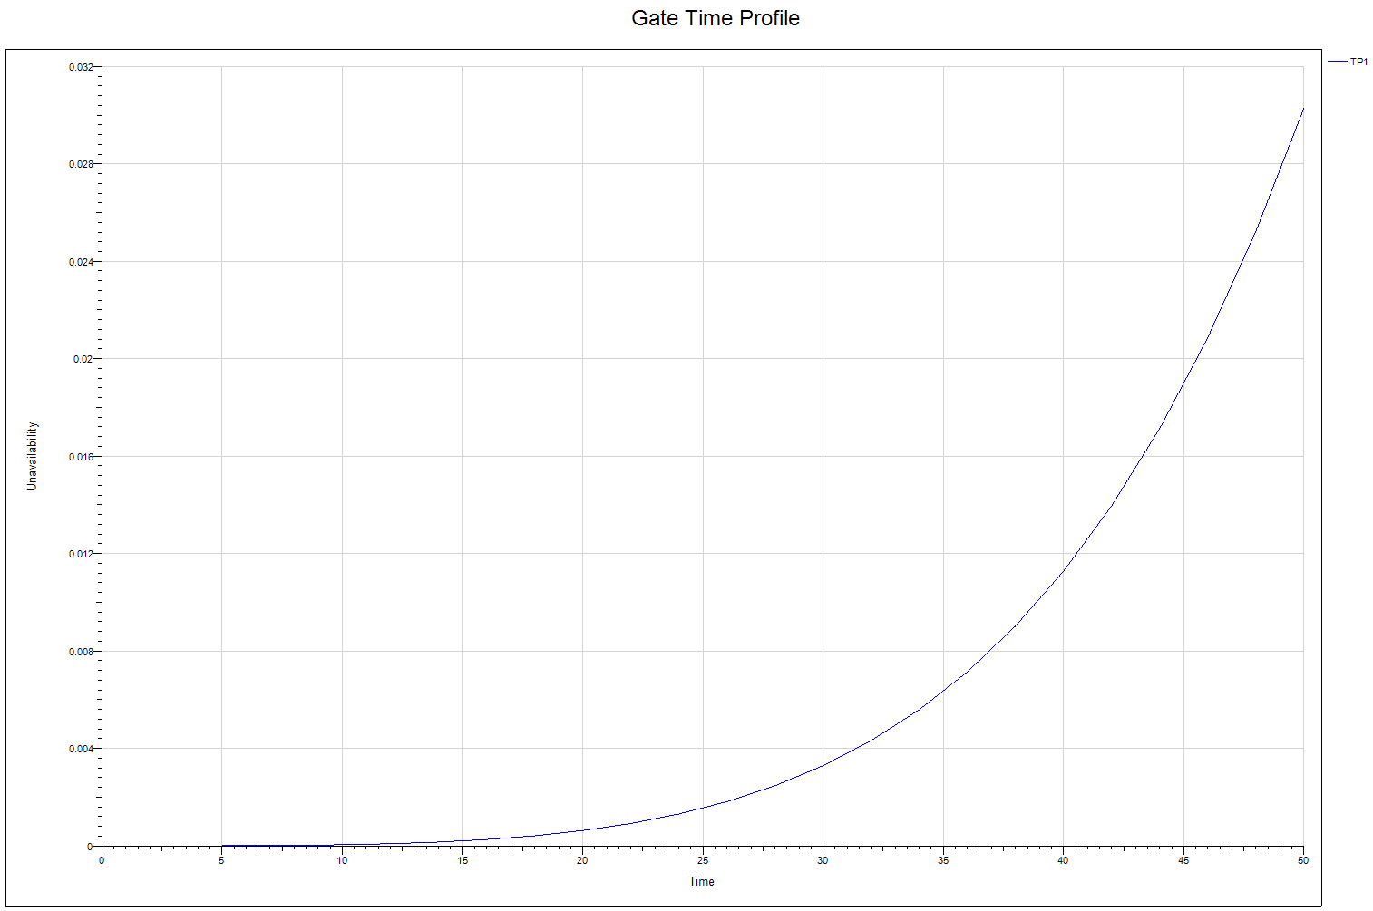

Consequences and Event Tree
A consequences event tree was developed based on failure, repair, and site disruptions. The consequences vary depending on the type and level of failure and also, how they impact loss of pool, power, and navigation. The primary driver for the unreliability is the failure of the relay cabinet (RC1), aged conductors and local controllers.
The first node of the event tree was whether a failure occurred or not. Assuming a failure occurred, three consequence levels were considered. These include:
- Minor Failure
A failure on the conductors between the control room and relay cabinet, and relay cabinet to spillway gate controllers will not affect the spillway gates functionality. The spillway gates can be controlled locally without interfacing with the relay cabinet.

- Major Failure
A failure on the local controllers at the gate will not affect the controls of the gates for a long period of time. The controller can be repaired with the replacement of faulty parts. The gate can still be operated remotely, while the local controllers are repaired.

- Catastrophic Failure
A failure on the relay cabinets, RC1 and RC2 which are well past their design life, will lose remote controls at the powerhouse. The spillway gates can still be operated from the local controls at each gates with no loss to pool, power, or navigation. There may be impacts to spill patterns and volumes for fish passage if the operators are not able to make the necessary real time changes, on the time scale necessary, utilizing only local controls. Additionally, to match the spillway flow to river flow, as part of the fish passage requirements, a sudden increase in workload may result in staffing constrains.

Investment Strategies

Maintain Base Condition
The electrical system uses a fix-as-fails maintenance strategy on many of its components. The fix-as-fails strategy assumes that components are replaced only when deemed to be unsafe, out of compliance, extremely worn out, or at their failure point. Baseline maintenance is defined as consisting of preventative and fix-as-fail practices to maintain the electrical system. Furthermore, this can be achieved by replacing faulty electrical parts within a short period of time.

Advance Maintenance
During the baseline analysis, it was found that some maintenance activities were very thorough preventative maintenance and actually could be considered as advance maintenance. Note that the control system has redundancy. A fix-as-fails strategy would be more advantageous than spending additional funds in advance of failure.

Scheduled Repair
There is no scheduled repair work planned.

Rehabilitation: Immediate and Scheduled
There is no immediate or scheduled rehabilitation work planned at this time.

Power Distribution

General
There are two main 4160V feeder lines feeding switchgears DQ1, DQ2, DQ3 and DQ4. DQ1 and DQ2 switchgears feed the spillway gates and can be backed up with a 480V generator during a power loss. DQ3 and DQ4 are fed by oil switches that are tapped of the two 4160V feeder lines.
The switchgears and oil switches were all installed in the 1950s. The oil switch on DQ3 has been in use beyond its design time and has now become a safety concern. Due to an immediate safety risk, the oil switch on DQ4 was put out of service. A catastrophic failure on DQ3 can cause damage to power lines, communications, and controls.

Reliability Analysis
A Weibull analysis was utilized for the reliability analysis. If one of the 4160V feeders failed, power will still be available from the redundant feeder to the spillway gates. If both the 4160V feeders failed, the emergency generator will be mobilized for DQ1 (spillway gates 1-11) and DQ2 (spillway gates 12-23). The gates can only be inoperable for a very short time. If the existing DQ3 oil switch fails and causes fire at nearby controls, communication and both 4160V feeders, a backup generator would then be used to restore power to the spillway gates.
The reliability can be increased by replacing the feeders and the oil switch which are beyond their design life and significant problems are expected as the equipment ages further. The intent is to reduce safety, risk, and failure.

Failure Mode Description
The current year (2019) overall probability of failure to operate 4160V feeders is 1.38%. There are two 4160V feeders. Both 4160V feeders feeds switchgear DQ1 and DQ2, one 4160V feeds DQ3 via oil switch and other 4160V feeds DQ4. The oil switch upstream of DQ4 was removed due to safety and reliability reasons. The major factor driving the unreliability and safety concern is the oil switch upstream of DQ3 that was installed in the 1950s. Removing the oil switch from service and installing new gear will reduce the failure to 10%. This will increase safety and reliability.
If power were to fail for the spillway gates, a 480V emergency generator will be mobilized providing power to all the gates, through DQ1 and DQ2.
Due to the current condition of the oil switch, the engineers at the site have determined that there is an extreme high risk of a fire breakout. The fire can potentially cascade to nearby utilities causing damage to control and communication wires.

Hazard Rates
A hazard curve was created for a single Tainter gate. The hazard curve was created from the Isograph Reliability Workbench program. The age shown in the curve is based on historic data provided by the project and the power distribution was modelled assuming 50 years of age. The hazard rate indicates how the system degrades over time and was calculated from the output of the Isograph Reliability Workbench fault tree model. The unreliability graph is shown below.
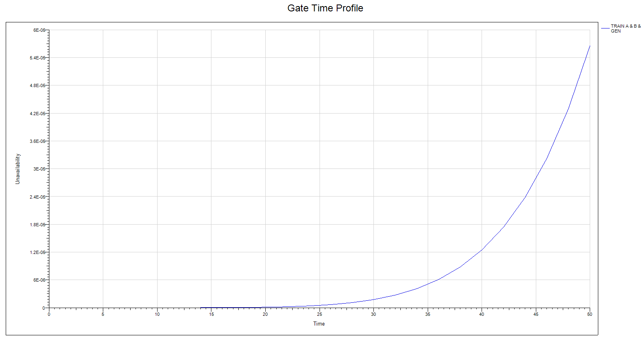

Consequences and Event Tree
A consequences event tree was developed based on failure, repair and site disruptions. The consequences vary depending on the type and level of failure and also how they impact loss of pool, power and navigation. The primary driver for the unreliability is the loss of 4160V power to DQ1 and DQ2 that feed the spillway gates.
The first node of the event tree was whether a failure had occurred or not. Assuming a failure, three consequence levels were considered. These includes:
- Minor Failure
A failure on one of the 4160V conductors feeding switchgears DQ1 and DQ2, will not affect the spillway gates, loss of pool or navigation. DQ1 and DQ2 both have redundant 4160V power feed. Repairs are minor and does not require immediate repairs for spillway gate functionality.
- Major Failure
A failure on both of the 4160V conductors feeding switchgears DQ1 and DQ2, will also not affect the spillway gates, loss of pool, or navigation.
- Catastrophic Failure
Due to the higher likelihood of failure on the oil switches from the 1950s, the oil switch on DQ4 was removed from service. It was found critical to replace the oil switch on DQ3 and DQ4 with a 4160V switch breaker combination device to reduce arc flash hazard and fire to the nearby utilities, such as parallel 4160V feeders, communication, and controls cables.

Failure of these switches could potentially affect well and sewage pumps. Well pumps provide portable, industrial, and fire suppression water as well as generator bearing cooling water (Reference: UFR Oil Switch Replacement – FY2017). However, with generator backup and local controls at the gates, a catastrophic fail will not cause loss of pool or navigation. Additionally, the cost to replace the oil switches were estimated at $1,518,580.

Investment Strategies

Maintain Base Condition
The electrical system uses a fix-as-fails maintenance strategy on many of its components. Preventative maintenance is also a part of the baseline analysis. The fix-as-fails strategy assumes that components are replaced only when deemed to be unsafe, out of compliance, extremely worn out, or at their failure point. Baseline maintenance is defined as consisting of preventative and fix-as-fail practices to maintain the electrical system.
Regular maintenance of the existing diesel generator includes periodic inspections and monthly testing of the generator.

Advance Maintenance
During the baseline analysis, it was found that some maintenance activities were very thorough preventative maintenance and could be considered as advance maintenance. Note that the power supply system has redundancy. A fix-as-fails strategy would be more advantageous than expending additional funds in advance of failure.

Scheduled Repair
No scheduled repair.

Rehabilitation: Immediate and Scheduled
The Scheduled Rehabilitation Strategy involves the optimally timed investment for electrical equipment replacement. The immediate rehabilitation strategy allows for a more near term investment and lumping components into contracts for efficiency, favorable bids, specialized contract services, and etc. The immediate and scheduled rehabilitation strategy is to replace the oil switch upstream of DQ3 and DQ4 with a 4160V switch breaker combination device.

Economic Analysis

Purpose

Methodology/Procedure

Description of Model

Baseline Condition

Benefits

Costs

Alternative Plans

Evaluation

Environmental Considerations

Background
The Corps and Bonneville Power Administration (BPA) have undertaken a wide range of measures to improve fish passage and survival through the Federal Columbia River Power System (FCPRS) over the past several decades. For example, the Corps has invested over two billion dollars into fish facility improvements as part of the Columbia River Fish Mitigation (CRFM) program funded by Congress. BPA is additionally required to invest in fish and wildlife improvements throughout the basin, with FY17 fish and wildlife costs of $396.7 million for example. The long-term impact of a notable failures such as a spillway breach would likely last for decades, if not longer, due to the loss of public trust and consequent additional legal requirements.
As part of operating the FCRPS, NMFS and USFWS have issued the Corps, BPA, and Bureau of Reclamation (FCRPS Action Agencies) Biological Opinions (BiOps) for the operation and maintenance (O&M) of the FCRPS including The Dalles Lock and Dam. Currently the Action Agencies are operating under a BiOp from NMFS issued in 2019 and a separate BiOp from USFWS. As part of the current NMFS BiOp, similar to previous NMFS BiOps, the Corps operates the FCRPS dams under an annual Fish Passage Plan (FPP) with spill occurring at The Dalles Dam from 10 April through 31 August to provide a major passage route for juvenile salmon and steelhead migrating downstream. Any failure at The Dalles that results in the inability to spill water during the spill season could potentially have significant legal and biological consequences for the ESA-listed salmon and steelhead that pass The Dalles Dam. While other downstream passage routes exist, the spillway is an important fish passage route as it typically passes the majority of fish and is the preferred passage route as reflected in the FPP.
Should spillway failures result in deviations from FCRPS BiOp requirements for fish passage, the Corps would likely have to implement a variety of measures to offset the loss of the spillway passage route for juvenile salmonids until repairs are completed. In addition, adult salmonid passage routes may be impacted as well with multiple potential means for violating FCRPS BiOp and FPP criteria, whether it be through loss of pool and ladders therefore running dry or creation of other potential passage barriers such as passage delays through hydraulic barriers at ladder entrances for example. While repairs are completed, appropriate measures would have to be taken for both juvenile and adult fish and would largely depend on the scale and duration of outages. For example, adult fish may need to trapped at a location below The Dalles and transported via truck above The Dalles to continue their upstream migration to their spawning grounds. A location and means of collecting adult fish would need to be determined and a temporary facility potentially may need to be constructed as no such facility currently exists. Collecting downstream migrants in a timely manner would be virtually impossible at The Dalles. This could have severe implications for two entire year classes of all salmon, steelhead, and Pacific lamprey species – both the returning adult year classes and the outgoing juvenile year classes. Considering thirteen stocks of Columbia River salmon and steelhead are already ESA-listed, and ten of these pass The Dalles Dam, the population viability for these fish could be significantly affected. The Dalles Dam is a mainstem Columbia River facility and thus important for fish passage. The Corps would be in serious breach of the BiOp with commensurate legal consequences dependent on the scope, scale, and duration of spillway failures.

National Environmental Policy Act (NEPA)
Under the National Environmental Policy Act of 1969 as amended (42 USC 4321), federal agencies are required to assess and disclose the effects of proposed actions on the environment before making a decision to proceed. At present, the appropriate level of NEPA documentation appears to be an Environmental Assessment, to be prepared by the Corps according to the procedures for implementing NEPA, specified in 33 CFR §230. The EA will evaluate effects to the following environmental resources: vegetation, soils, wildlife, fish, threatened and endangered species, invasive species, air quality, water quality, hydrology, wetlands, socio-economics, visual quality, cultural resources, climate change, and hazardous materials.
Once the TSP has been selected, the Corps will begin preparing a draft EA for release to potentially affected parties. The draft EA will be available to public and agency stakeholder for a 30-day review and comment period. Comments received during this period will be considered in the final EA. After such time, the Corps will determine if the effects of the TSP would cause significant impacts to the quality of the human environment, prompting the need for an Environmental Impact Statement, or whether conversely, the Corps will release a final EA and a Finding of No Significant Impact (FONSI) to affected parties.

Endangered Species Act (ESA)
Under the Endangered Species Act (ESA), the Federal Columbia River Power System (FCRPS) has been issued a Biological Opinions (BiOp) by the National Oceanic and Atmospheric Administration (NOAA, also known as NMFS) for the operation and maintenance of the FCRPS. The previous 2008/2010 FCRPS BiOp recommended Reasonable and Prudent Alternatives (RPAs) to avoid jeopardizing the continued existence of thirteen species of salmon and steelhead affected by the FCRPS. These RPAs, were a comprehensive suite of actions to protect these thirteen ESA-listed salmonids, are implemented by the FCRPS Action Agencies, including the U.S. Army Corps of Engineers (Corps) and the Bonneville Power Administration. The Action Agencies are currently operating under a new 2019 BiOp while a new Environmental Impact Statement (EIS) and BiOp are being developed for anticipated implementation starting in 2021.
As part of the implementation of previous and current BiOps, the Fish Passage Plan (FPP) was developed by the Corps’ Northwestern Division and is a living document that is updated annually through a regional forum (the Fish Passage Operations and Maintenance technical work group). The FPP lists operations and maintenance requirements for Corps’-operated Projects, including The Dalles Dam, to limit any negative impacts that dam operation may have to ESA-listed fish species. The FPP includes but is not limited to turbine operations, spill patterns, when scheduled maintenance can occur, how unplanned outages can be coordinated, etc. The FPP thus plays an important role in how The Dalles Dam is operated for both juvenile and adult fish as they migrate past the dam. It can be found online at http://pweb.crohms.org/tmt/documents/fpp/.
Unplanned and uncoordinated deviations from the FPP mean that the Corps is out of compliance with the FPP and in violation of NOAA’s FCRPS BiOp. These violations are recorded and in worst case could result in legal action against the Corps. Violations are minimized by following the recommendations of the FPP when emergencies occur. Major deviations from the FPP such as a failure of the spillway during the downstream juvenile migration season (10 April – 31 August each year) would be a serious breach of the BiOp as the spillway is the major and preferred juvenile salmon migration route. Other violations such as the failure of an individual spillway gate such that it cannot be operated in accordance with the FPP may result in less than optimum spill patterns at the dam. Spillway bays 1-8 are used to pass juvenile salmonids downstream during the spring and summer and are of the greatest importance in the FPP context. However spillbays 9 and above also have potential fish passage benefits depending on specific scenarios being addressed. Spill patterns have been carefully selected to optimize safe passage and survival. Any disruption to the approved spill patterns could physically harm out-migrating fish or make them more susceptible to predation immediately downstream of the project. While the effect on salmon survival difficult to quantify in the context of this MRER, it is nonetheless an important conceptual consideration.
If commercial navigation through The Dalles navigation lock and/or tailrace is impacted due to failures / is out-of-service, barging of juvenile salmon and steelhead from the Corps Snake River dams to below Bonneville Dam could be interrupted during outmigration. If barges are unable to pass through The Dalles Dam project, transported fish would need to be released upstream resulting in loss of benefits of the transport program as well as subjecting these fish to potentially degraded passage conditions through TDA. As a result, there would be some impact on future adult salmon returns that would have economic consequences for sport, commercial and Native American fisheries. These potential losses are difficult to quantify in the context of this MRER report, however providing safe fish passage and meeting the Corps ESA requirements is of notable importance to the Corps.
In addition, the Corps will need to work with USFWS if there may be potential impacts to ESA-listed Bull trout as part of executing construction activities resulting from this MRER. While there is a current USFWS BiOp for the operation and maintenance FCRPS that may cover construction activities identified for implementation as a result of this MRER, there is likely to be a new USFWS BiOp for operation and maintenance of the FCRPS at the time work described herein is implemented. It may also be necessary to consult with USFWS on this MRER depending on the tentatively selected alternatives.

Clean Water Act (CWA)
The Clean Water Act (CWA) governs the release of pollutants into waterways.
Section 401 of the CWA requires a certification from the state project-related discharges to waters of the U.S. would not violate the state’s water-quality standards. EPA retains jurisdiction in limited cases. The project is not likely to avoid the discharge of pollutants (including suspended sediments, uncured concrete, and oil) into the Columbia River. Additionally, means of isolating the in-water work area from active river flow are not readily forthcoming, increasing the risk of pollutants entering a Water of the U.S. Thus, the work would require two water quality-certifications: one from the Oregon Department of Environmental Quality and one from Washington State Department of Ecology.
Section 404 of the CWA regulates the discharge of dredged or fill material into waters of the U.S. The repairs to the spillway involve placement of structures within the Columbia River and would therefore constitute a placement of fill material into a water of the U.S. The Corps has permitting responsibility under Section 404 of the CWA to place this material. However, the Corps does not issue itself a 404 permit; instead, the Corps applies the 404(b)(1) guidelines (40 CFR Part 230). Only when there is no practicable alternative would any discharge of fill material occur in wetlands or other waters of the U.S, and such actions may require mitigation.

National Historic Preservation Act (NHPA)
Section 106 of the NHPA requires agencies to consider the potential effects of their projects and undertakings on historic properties eligible for, or listed on, the National Register of Historic Places. Historic properties include archaeological sites or historic structures or the remnants of such sites or structures.
Once the Tentatively Selected Plan is known, Corps cultural resources staff will determine the potential effect of the project on known or unknown historic properties. The following items are analyzed: the nature of the proposed activity and its effect on the landscape, the likelihood that historic properties are present within a project area, whether the ground is disturbed by previous land-use activities and the extent of the disturbance, and listings of known archeological or historic site locations (including site databases, areas previously surveyed, or listings of sites on the NRHP).
Section 106 consultation will need to be conducted for activities that involve earth disturbance, disposal of soil, equipment operation over land, road construction, and alterations to structures that are more than 50 years old (including The Dalles Dam itself, which was constructed in 1957).

Other Environmental Laws and Regulations
The recommended plan is expected to comply with all laws and regulations; this compliance will be documented in the Environmental Assessment prepared by USACE prior to award of the contract for construction. These laws include, but may not be limited to: the Clean Air Act; Comprehensive Environmental Response, Compensation, and Liability Act and Resource Conservation and Recovery Act (CERCLA); Executive Order 13175, Consultation and Coordination with Indian Tribal Governments; Executive Order 12898, Environmental Justice; Executive Order 13751, Invasive Species; Executive Order 13186, Migratory Birds; Executive Order 11990, Protection of Wetlands; Magnuson-Stevens Fishery Conservation and Management Act; Marine Mammal Protection Act; and Migratory Bird Treaty Act.

Project Cost Estimate

Project Cost Components

Tainter Gate Replacement - Mechanical
In 2015, a $4.63 million contract was awarded to Knight Construction for the Hills Creek Dam Spillway Gate Rehabilitation project. Of this cost, $1.05 million was allocated for fully rehabilitating the hoist system for Gate 1 at Hills Creek which included brake-motors, worm gear reducers, line shaft bearings, parallel shaft reducers, pinion and bull gears, couplings, limit switches, hoist drums, gate rollers, machinery platform locating and doweling. Calibration, testing, and commissioning of the gate is included in the cost (Hills Creek P&S 2015). Using the yearly cost indexes from the Civil Works Construction Cost Index System (CWCCIS, EM-1110-2-1304 31 March 2018), the escalated cost for this scope is $1.13 million for FY 2019. Since Hills Creek and The Dalles have similar Tainter gate radii, it is assumed that the cost for this work scope at The Dalles is comparable to this cost at Hills Creek.

Tainter Gate Replacement - Structural (Single End Frame Replacement)
In the same 2015 contract for Hills Creek Dam, $1.59 million was allocated for structural work on Gate 1 at Hills Creek which included fabrication and installation of the gate trunnion end frame, trunnion yoke, wire rope for the hoist system, rib stiffeners, lead-based paint abatement, painting, removal and replacement of seals, and structural demolition (Hills Creek P&S 2015). Escalated to FY 2019, the cost for this scope is at $1.71 million. Since Hills Creek and The Dalles have similar Tainter gate radii, it is assumed that the cost for this work scope at The Dalles is comparable to this cost at Hills Creek.

Tainter Gate Replacement - Electrical
The 2015 contract for Hills Creek Dam allocated $417,600 for furnishing and installing power distribution systems on all three gates. Per gate, this cost was $139,200 of which included costs for the redundant feeder, transfer switches, and generator connections, the removal of all wiring and exposed/accessible conduit, and furnishing and installing lighting and convenience receptacles. The installation of new electrical components included the control panels and hand control stations. Costs associated with the removal of the existing control panel, associated wiring, and accessible conduit are included (Hills Creek P&S 2015). Escalated to FY 2019, the cost for this scope per gate is at $149,800. Since Hills Creek and The Dalles have similar Tainter gate radii, it is assumed that the cost for this work scope at The Dalles is comparable to this cost at Hills Creek.

Plates and Stiffeners - Structural
In 2018, a $13.1 million contract was awarded to Northbank Civil and Marine, Inc., to rehabilitate the Tainter gates at Detroit. Of this cost, $1.20 million was allocated to structural work for gates 5 and 6, or $600,000 per gate. Structural work involved fabrication and installation of steel weldments, weld repairs on existing strut arms, lead-based paint abatement, painting, and seal replacement (Detroit Tainter Gate Rehab 2018). Escalated to FY 2019, the cost per gate for this structural scope is at $612,000. An additional upscale factor of 1.2 was applied based on differing pier spacing for Tainter gate widths between The Dalles and Detroit dams (50 feet and 42 feet respectively) such that the price for adding plates and stiffeners to one gate at The Dalles is expected to be $734,500 for FY 2019.

Trunnion Rehabilitation - Structural
In 2010, a $1.49 million contract was awarded to rehabilitate trunnions and replace wire ropes at Fall Creek Dam and Lookout Point Dam. Of this cost, $102,300 was allocated to the rehabilitation of the trunnions at one gate. The scope included the complete removal and replacement of existing bushings, pins, keeper plates, thrust washers, and lock bolts of which were replaced with new parts (Fall Creek LOP Rehab). Escalated to FY 2019, the cost per gate for trunnion rehabilitation is $123,300.

Spillway Gantry Crane – Electrical, Mechanical, Structural Combined
A 2016 report looked into the replacement and rehabilitation of a gantry crane at The Dalles. The report found that rehabilitating a gantry crane is 35% more expensive than procuring a new crane. The report’s estimate for a new gantry crane was $16.0 million (TD E-Crane Phase 1a). Escalated to FY 2019, the cost of a new gantry crane from the report is at $17.0 million.
In 2017, a $13.9 million contract was awarded to REEL COH for the replacement and installation of a 585 ton emergency gantry crane at John Day Dam. Escalated to 2019 using the CWCCIS yearly cost indexes, $14.5 million was spent on a new emergency gantry crane at John Day.

Emergency Stoplogs
In 2011, a $984,900 supply contract was awarded to Oregon Iron Works for the procurement of seven new stoplogs for John Day. The unit price was $140,700 per stoplog. Escalated to FY 2019, the price to procure a new stoplog for John Day is $160,000 (JD Stoplog Supply Bid Abstract). The pier to pier lengths of John Day and The Dalles are comparable (52 feet and 50 feet respectively), so it is assumed that the cost to manufacture new stoplogs at The Dalles will be similar to that for John Day. The Dalles requires ten stoplogs per gate, amounting to $1.60 million to procure new stoplogs for one gate at The Dalles.

Emergency Closure System – Electrical, Mechanical, Structural Combined
A 2010 report looked into providing an emergency closure system for one spillway at John Day in the event of a gate failure. The emergency closure system is mobile and therefore able to close any one gate that fails. From the report, the fabrication of the emergency closure system itself was estimated to be $6.38 million without contingency (JD Emergency Closure Gate System Cost Estimate). Escalated to FY 2019, this fabrication cost is $7.72 million.
In the scenario of a total catastrophic failure where the emergency gate system is deployed because the failed gate is washed away and a new gate needs to be refabricated and installed, the total cost (including the fabrication of the emergency gate system) from the report amounted to $12.5 million without contingency. Escalated to FY 2019, this cost is $15.2 million. With an approximate 26.6% contingency (as provided by the report), the cost is $19.7 million for FY 2019 ($16.3 million in FY 2010).

Replacement Costs
Item Description | Quantity | Unit Cost ($M) |  | Total Cost ($M) | Notes
Item Description | Quantity | 1st Gate | After 1st Gate | Total Cost ($M) | Notes
Tainter Gates 1-9 (Mob/Demob, Struc, Elect, Mech) | 9 | $3.4 | $3.1 | $28.2 | Historical Escalation of Hills Creek (2015)
Mob/Demob |  | $0.4 | $0.1 | $1.2
Mech |  | $1.1 | $1.1 | $9.9
Elect |  | $0.2 | $0.2 | $1.8
Struct |  | $1.7 | $1.7 | $15.3
Tainter Gates 10-23 (Mob/Demob, Struc, Elect, Mech) | 14 | $3.4 | $3.1 | $43.7 | Historical Escalation of Hills Creek (2015)
Mob/Demob |  | $0.4 | $0.1 | $1.7
Mech |  | $1.1 | $1.1 | $15.4
Elect |  | $0.2 | $0.2 | $2.8
Struct |  | $1.7 | $1.7 | $23.8
Spillway Gantry Crane and Emergency Stoplogs | 1 | $18.6 |  | $18.6 | Escalation of TD E-Crane Report (2016) and JD Stoplogs (2012)
Emergency Closure System | 1 | $15.2 |  | $15.2 | Escalation of John Day MRER
DQ3 & DQ4, Oil Switch, & Feeder Upgrade | 1 |  |  | $0.72 | see Electrical Spreadsheet
Control Upgrade (PLC, RC1, RC2, & Control wiring) | 1 |  |  | $1.4 | see Control Upgrade tab

Advance Maintenance Costs
Item Description | Quantity | Unit Cost ($M) |  | Total Cost ($M) | Notes
Add stiffeners and plates to end frames (reinforce) | 23 | $0.74 | $0.52 | $12.2 | Historical Escalation of Detroit (2018)
Wire Ropes & drum | 46 |  |  | $0.0 | CY2000 gates 1-9 were replaced

Recommended Plan
This Major Rehabilitation Report recommend a repair plan for The Dalles Lock and Dam to resolve structural, mechanical, and electrical reliability problems at the project. The intent is to make critical features at The Dalles more reliable so that project operations can be performed without disruption.
The estimated cost for the recommended plan, including design and construction management, is approximately $XX.X million. The benefit-to-cost ratio is X.X to 1. The work is recommended for immediate implementation.

Decision Matrix
To assist with making decisions on how best to distribute rehabilitation funding and efforts, the PDT used a decision matrix to rank certain alternatives and compare their respective benefits to the project.

Plan Features

Rehabilitation of Spillway Gates 1 through 9
The key features of the Tentatively Selected Plan (TSP) included three major rehabilitation efforts: full structural and mechanical rehabilitation of spillway gates 1 through 9, upgrade electrical power distribution main switches DQ3 and DQ4, upgrade electrical control relay cabinets RC1 and RC2. These three efforts will provide several benefits to the Project in the areas of fish passage efficiency, O&M burden and overall reliability of spillway gates 1 – 9.

Structural Rehabilitation
A structural rehabilitation of a Tainter gate at The Dalles would be largely identical to the action performed earlier at Hills Creek Dam in 2017. Both gate end frames would be replaced with upgraded sections conforming to the newest HSS guidelines. The use of more modern steel will also ensure a more robust frame system. In addition to the end frames, the trunnion yoke, trunnion pin and trunnion hub will also be replaced with a modern and reliable design. The trunnion anchor systems cannot be successfully rehabilitated without significant demolition to the spillway piers, so anchorage rehabilitation is not recommended, but should be inspected regularly.

Mechanical Rehabilitation
Mechanical rehabilitation of gates 1 through 9 would involve replacement of the hoist equipment. The new equipment would likely be similar to replacements that have been performed on spillway Tainter gate rehabilitations performed in the NWP Willamette Valley. One example is from Hills Creek Dam which has similar sized gates as The Dalles. The drawing clip shown in Figure 8-1 shows a plan view of the new Hills Creek spillway gate hoist. This new system is still a wire rope electric hoist system however, it incorporates redundant motors and brakes. In addition, the gearing is simplified by eliminating the open gear set and accomplishing the full reduction ratio of the hoist with enclosed reducers. The drum is then mounted on the output shaft of the parallel shaft reducer. Overall, this newer design improves the reliability by providing redundant hoist motor and brakes.

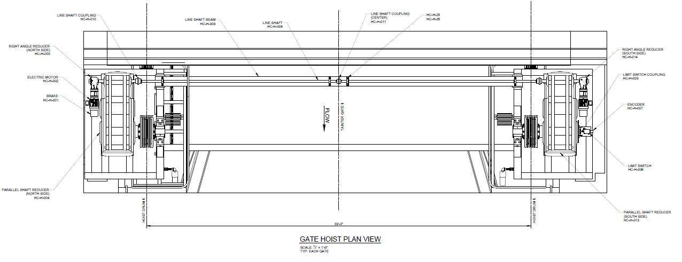
Figure 8-1 Hills Creek Dam Rehabbed Spillway Gate System

Rehabilitation of Spillway Electrical Distribution System
The current condition of the oil switches DQ3 and DQ4 are beyond its service life and have become a safety hazard. It is highly recommended to replace DQ3 and DQ4 to prevent fire breakout to electrical and control equipment, and all surrounding equipment.

Rehabilitation of Spillway Electrical Control System
The aging relay cabinets (RC1 and RC2) have become unreliable and unsafe for future preparations. A failure with the RC1 and RC2 may cause loss of controls from the control room and at the local controls. It is recommended to upgrade the controls with PLC system.

Economic Considerations

Construction Considerations

Schedule

Other Recommendations

Advance Maintenance Effort
Due to the low benefit-to-cost ratio for rehabilitation of The Dalles Dam, it is understood that the likelihood of approval of funding for a major rehabilitation effort is low. The PDT chose to recommend an alternative to the major rehabilitation effort. The PDT recommends an advance maintenance effort be pursued to offer the most value to the project with the lowest cost. The proposed major maintenance effort includes:

Structural Rehabilitation of Tainter Gate 9
See the description in Section 8.1.1.1 for more details on this action.

Upgrade of Electrical Controls RC1 and RC2
The major maintenance for the RC1 and RC2 would be to troubleshoot and replace faulty relays. It will be recommended to carry spare relays when quicker repair time.

Upgrade of Electrical Power Distribution DQ3 and DQ4
The major maintenance for the DQ3 would be to put it out of service and do a direct tap off the main feeder. DQ4 is already out of service.

